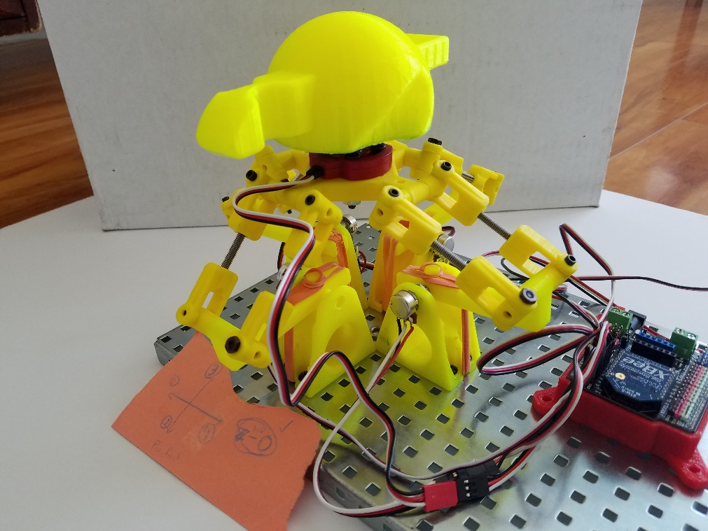

3D Joystick Project

Robotics 4

2016-2017

Table of Contents

Description 5

Why? 5

Parts List 5

Goals 5

Timeline 6

Budget 7

Parts List 7

Money Source Planning 8

Funding Timeline 8

Expenditures 8

Photos 9

Daily Log 8/22/16 11

Daily Log: 8/24/16 12

Daily Log: 9/20/16 13

Daily Entry: 10/18/16 14

Daily Entry: 10/24/16 16

Daily Log: 11/1/16 18

Daily Log: 11/7/16 19

Daily Log: 11/9/16 21

Daily Log: 11/13/16 23

Daily Log: 11/15/16 24

Daily Log: 11/28/16 27

Daily Log: 1/24/17 29

Daily Log: 1/26/17 31

Daily Log: 2/9/17 33

Daily Log: 2/15/17 35

Daily Log: 2/24/17 37

Daily Log: 2/28/17 39

Daily Log: 3/2/17 41

Daily Log: 3/6/17 43

Daily Log: 3/14/17 45

Daily Log: 4/7/17 47

Daily Log: 4/21/17 48

Daily Log: 5/2/17 50

Final Images 52

Reflections 56

Overall Review 56

Meeting Goals 56

Future Applications 57

Lessons Learned 57

Final Code 58

# Description

This project will involve several aspects. The first component of the project will be the construction of a 3D joystick, one that can be used to control the flight of a drone in three dimensions: on the pitch, yaw, and roll axes. It will also include a rotation controller. This will be done in a method that involves 4 separate armatures that themselves are made of two components. This can be seen in the prototype that exists in the photos section. I will than implement that joystick as a method to control an actual drone.

# Why?

This project is important because it offers an excellent new way to operate the numerous drones in the robotics program. Additionally, in a big picture sense, joysticks like the one I will be creating will play an interesting part in the future. Drones are becoming a larger and larger field, so the opportunity to innovate in the control of those machines is an excellent one I am excited to capitalize on.

# Parts List

A large portion of this project will be 3D printed. The parts modeled in the prototype will be designed and custom printed to fit my needs. These components are represented on this list by 3D Printer filament.

|  |  |  |
| --- | --- | --- |
| Part | Purpose | Quantity |
| 3D Printer Filament | Custom parts | N/A |
| VEX IQ Parts | Prototyping | N/A |
| Potentiometer | For sensing the position of the joystick | 5 |
| Axel of short length and small diameter | Joints in the joystick | 5 |
| Axel Joints | For other joints in the joystick | 16 |

# Goals

Primary Goals

1. Create a functioning drone control mechanism
2. Control the drone in 3 dimensions, as well as rotation angle.
3. Create a stable and long lasting design that is sturdy and strong, but also mobile.

Secondary Goals

1. 3D Print most if not all components of the joystick
2. Incorporate wireless communication methods into the joystick itself
3. Include the ability to customize into the joystick, such that factors like height can be changed to be most comfortable for the user.

Roadblocks

* Interfacing whatever is designed with the drone will be a difficult task all its own. The two software interfaces used are very different.
  + I will attempt to overcome this issue by researching and trial and error.
* Configuring the ratios of the potentiometers in the joystick will take some math as well as trial and error. I imagine that this will be the most tedious part of the project, as the potentiometers have a tendency to become misaligned, and the calculations will have to account for some error.
  + I will just have to continue trial and error with this. I will have to put some time into seeing how various positions effect the potentiometer values.
* The 3D printer creates parts that while custom, can be fragile and finicky. Getting these parts to print both accurately and in such a manner that they last will be no easy task.
  + I will have to carefully design these parts, and perhaps go through multiple prints. If that does not work, I may have to investigate different filament types and print settings.

# Timeline

* By the end of October – Have a fully functioning prototype constructed and returning values
* By the end of December – Have all the parts necessary to complete construction of the actual joystick. This includes designing and printing all parts that are going to be custom 3D printed.
* By the end of February – Complete the assembly of the joystick such that is functioning and returning raw values.
* By the end of March – All programing complete for the project, the joystick is usable on a test vehicle that is made with a compatible software
* By the end of April – The joystick will be usable on a drone and fully complete.

# Budget

## Parts List

|  |  |  |  |
| --- | --- | --- | --- |
| Part | Quantity | Cost per Item | Total Cost |
| Arduino Mega 2560 | 1 | 45.95 | 45.95 |
| DFR Robot Leonardo w/ XBee Socket | 1 | 19.90 | 19.90 |
| Sensor Shield for Arduino Mega | 1 | 19.50 | 19.50 |
| Vex Potentiometer | 5 | 6.50 | 32.5 |
| 3D Printed Components (cost of filament, printer NOT included) | N/A | ~20.00 per spool | 20.00 |
| XBee 2mW Series 2 | 2 | 26.90 | 53.80 |
| XBee USB Adapter V2 Atmega8u2 | 2 | 17.90 | 35.80 |
| Joint Coupler | 16 | 1.52 | 24.32 |
| Vex 3 Wire Motor Extension Cable | 5 | 4.99 per pack of 4 | 10.00 |
| Vex 18 tooth Sprocket | 2 | 12.99 per pack of 4 | 12.99 |
| Vex Rubber Shaft Collar | ~30 | 5.99 per pack of 30 | 5.99 |
| 3 in. length .125” shafts | 9 | 5.49 per pack of 4 | 16.47 |
| Vex Rubber Bands #32 | 4 | 1.49 per pack of 20 | 1.49 |
| 2 in. length .125” shafts | 4 | 5.49 per pack of 4 | 5.49 |
| Vex 3 in. Standoff | 16 | 6.95 per pack of 4 | 27.8 |
| Vex Axel Collar | 5 | 7.99 per pack of 16 | 7.99 |
| Vex Bearing Flat | 4 | 4.99 per pack of 10 | 4.99 |
| Vex Base Plate | 1 | 29.99 per pack of 2 | 29.99 |
| Vex Advanced Metal Kit | 1 (various components used from this kit) | 69.99 | 69.99 |
| Vex 8-32 x .500” Screws | <50 | 4.95 per pack of 50 | 4.95 |
| Vex 8-32 Keps Nut | <50 | 2.99 per pack of 100 | 2.99 |
| Vex 8mm Plastic Spacer | 15 | 2.99 per pack of 20 | 2.99 |
| **Total** |  |  | **$455.80** |

## Money Source Planning

The main source of this funding will be through materials that have already been acquired by the school for student use. This constitutes the vast majority of the parts required. Other parts however may be required, especially if something breaks or is not functioning correctly. These funds could come from a grant I submitted earlier in the year for a related VTOL aircraft project, or further funding from the school.

## Funding Timeline

All parts will be acquired as the project begins. There will be no significant gaps between work, so it will be most efficient to have all parts on hand and available to be utilized whenever I am prepared to do so. Expectations to this will include further expenditures deemed necessary by parts breaking or unforeseen needs arising.

## Expenditures

The following table represents all parts purchased in addition to those included on the parts list.

|  |  |  |  |  |
| --- | --- | --- | --- | --- |
| Part | Quantity | Reason | Cost Per Item | Total Cost |
| XBee 2mW Series 2 | 2 | XBees that I had not working properly | 26.90 | 58.80 |
| XBee USB Adapter V2 Atmega8u2 | 2 | XBees that I had not working properly, could potentially include adapters | 17.90 | 35.80 |

# Photos

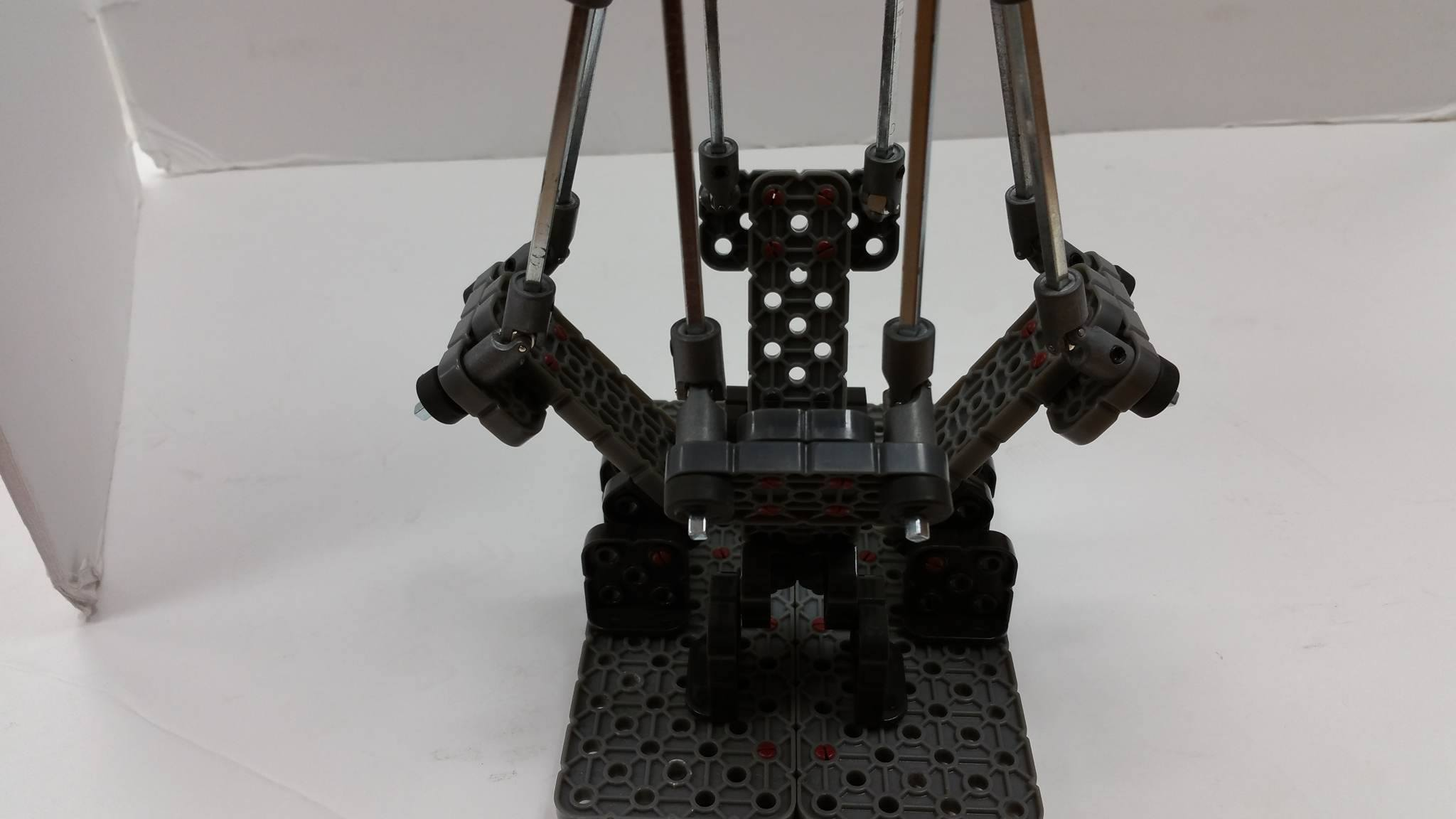These three photos represent the initial prototype of the 3D Joystick that I will be using to model my plan. They were taken after its construction, but before my work with the joystick itself.

This photo shows the joystick in a fully upright position. You can see where the arms of the joystick are connected to the lower arms.

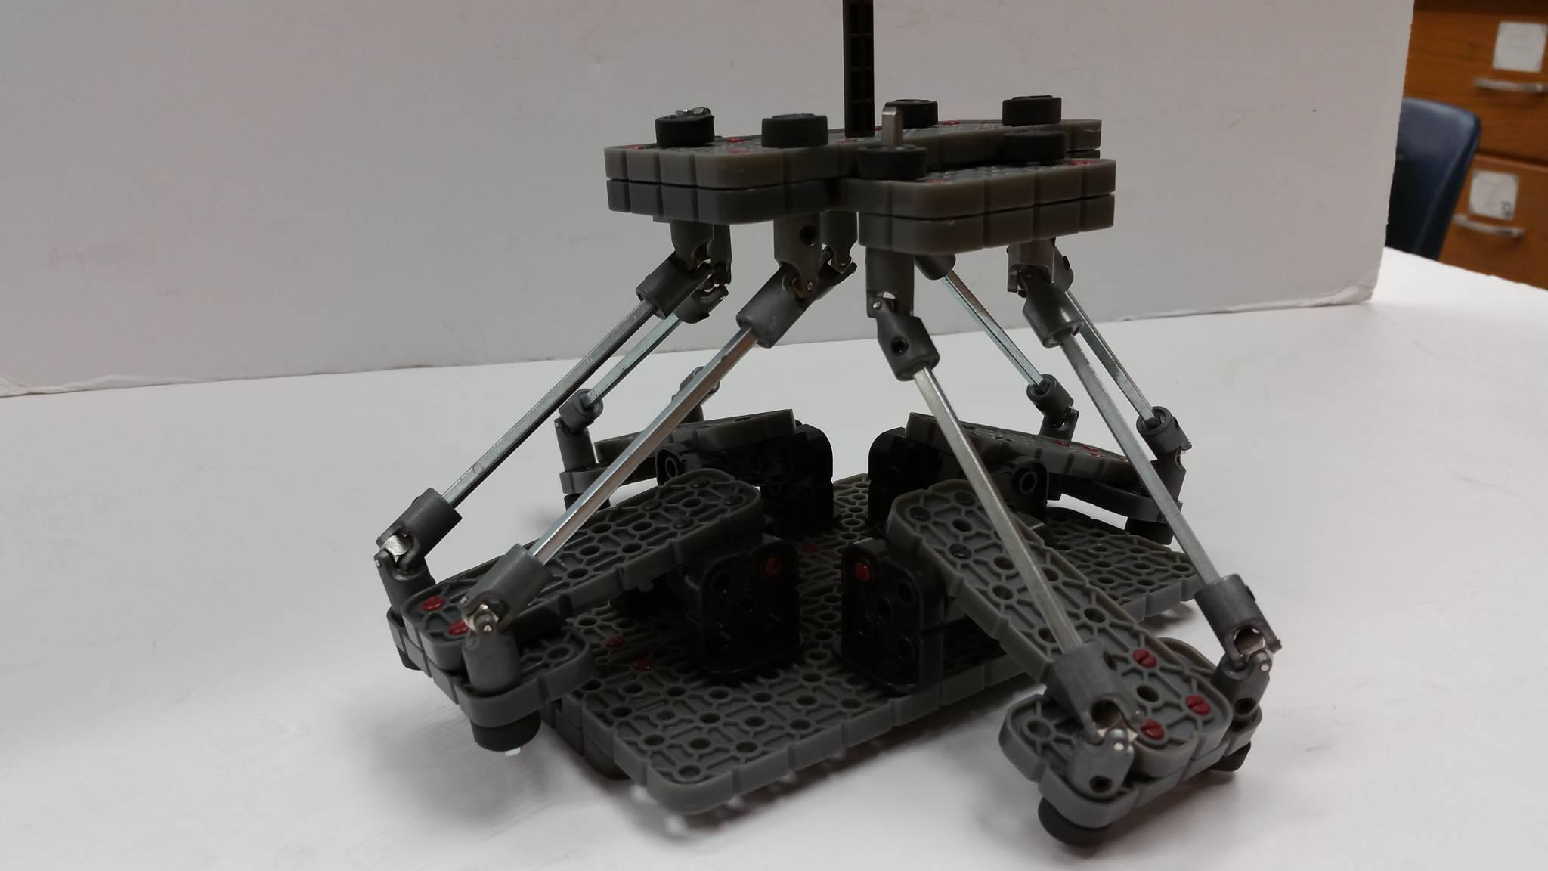This photo shows the joystick in a lower position. Here it can be noted how the lower arms extend a bit lower than their mounting, a design component that will be kept in mind later. The knob attached to the top of the joystick can also be seen.

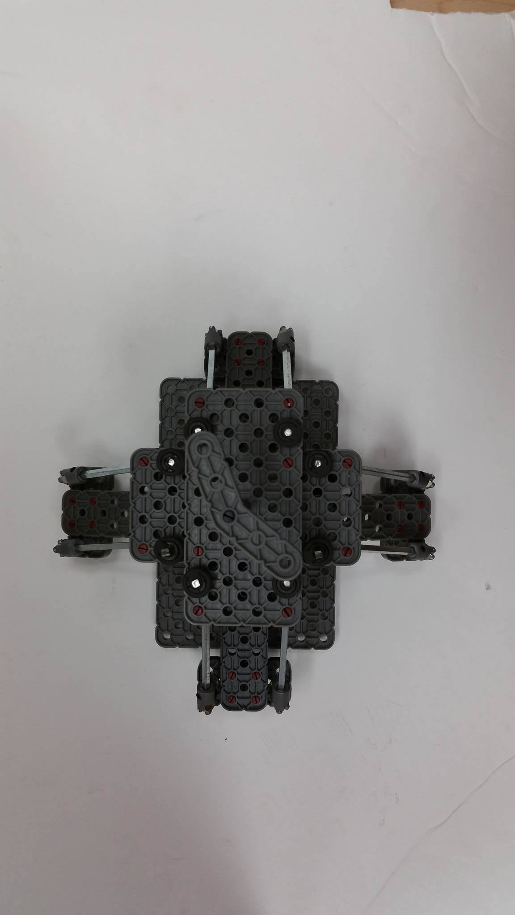This photo shows the prototype from above. The knob at the top of the joystick can be fully seen, as can the scale of the joystick itself.

# Daily Log 8/22/16

Goals

My goals for today are to acquaint myself with the prototype arm. I want to experiment with the design and get a feel for how the changes affect the actual joystick’s range.

## Accomplishments

Working with the joystick gave me a good idea for how everything works. The changes to length of arms and things certainly make a difference, which I feel as though I understand better now.

## Looking Forward

I will need to get some hard data about how the actual changes of arm length and things effects the range of the joystick. I hope to record that data going forward.

## Images

Included is an image of the prototype joystick.



# Daily Log: 8/24/16

Goals

My goals for today are to record some solid and useful data about how the various ranges of the joystick are effected by changing its configuration.

## Accomplishments

Working with the joystick, I made a table of changes to the prototype and their effects on range. I tried to be as accurate as possible, but it seems like some of the numbers may be off.

## Looking Forward

I want to examine how accurate these numbers are, and I also want to examine further changes.

## Images

Included is an image of the table of values I developed.

|  |  |  |  |  |  |  |
| --- | --- | --- | --- | --- | --- | --- |
| Arm Length | Leg Length | Distance X | Distance Z | Range X | Range Z | Range Y |
| 8.5 cm | 7.5 cm | 5 cm | 5 cm | 24 cm | 24 cm | 9.5 cm |
| 8.5cm | 7.5cm | 5cm | 8cm | 24 cm | 28 cm | 9.5 cm |
| 8.5cm | 6cm | 5cm | 5cm | 28cm | 28cm | 7.5cm |

# Daily Log: 9/20/16

Goals

My goals for today are to further experiment with the joystick, and to attach potentiometers if possible.

## Accomplishments

Working with the potentiometers, it soon became clear attaching them would be difficult. It was decided the best move forward was to move to the next prototype. The arms were again manipulated to experiment with how it effects range, but time limitations prevented me from getting actual measurements.

## Looking Forward

I am ready to move on to the next phase of prototyping, which I can hopefully begin next class. That will involve a lot more, and actually developing the joystick.

## Images

Included is an image of the prototype with potentiometers attached.

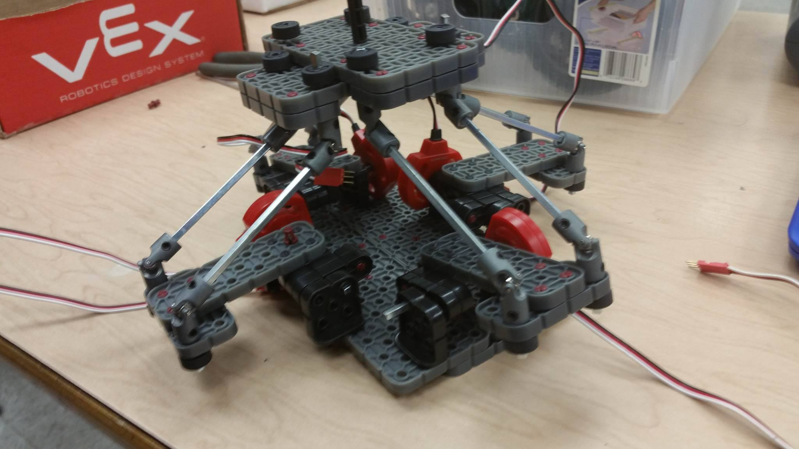

# Daily Entry: 10/18/16

## Goals

The goals for this day were to work with the new, metal prototype that Mr. Ness had developed. The old prototype was turning out to be structurally unsound, and not up to par. I wanted to determine the number of rubber bands, and their configuration, that would be needed in the end model before attaching the rest of the components. I’d also like to begin constructing the other sides if there is time.

## Accomplishments

I ended up mostly meeting the goals I set out to achieve. After some testing, I determined which rubber band configuration I want to use in the end model. I did not begin constructing the rest of the model though.

## Going Forward

Going forward, my next step is going to be finishing the new prototype. That means getting potentiometers and such attached as well. Once I do that, I will need to verify the rubber bands are working as desired. After that, assuming no further tweaks need to be made, I will begin working on software components of the project.

# Images

The images below show the new prototype at its starting phase. They are both set up for rubber band testing.

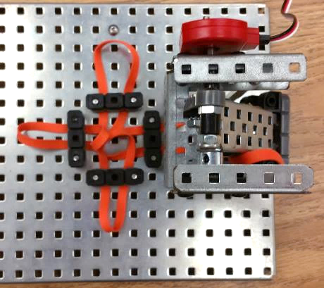

# 

# Daily Entry: 10/24/16

## Goals:

Today I want to finish the construction of the new prototype. To be completed, the structure needed to be completed on three sides, potentiometers needed to be attached, and some metal pieces needed to be adjusted. The rubber bands will also be retested.

## Accomplishments

I got the structure completed, including potentiometers and some new 3D printed components that Mr. Ness had developed. Mostly, my work today was reconstructing mirrored versions of the one existing structure that I had last time. Overall, it is very structurally stable, and the rubber bands are working great.

## Going Forward

Now that the prototype is finished, I will move on to wiring the joystick into an Arduino board. I need to get the 5 potentiometers connected, and then I will try to get them communicating with the board. I will also be correcting and tweaking the prototype as needed.

## Images

Included are images of the completed joystick build.

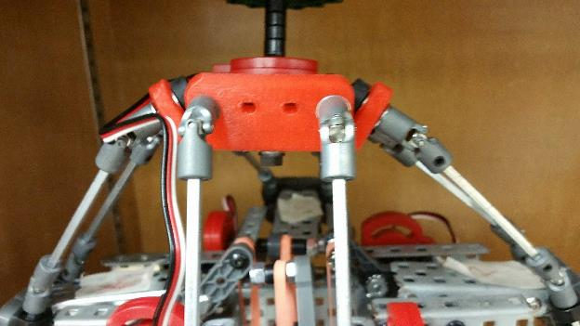

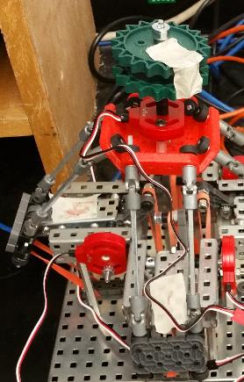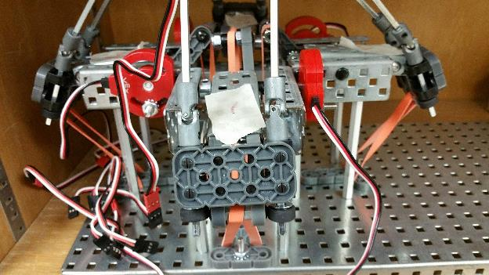

# Daily Log: 11/1/16

## Goals

My goal for today is to get the joystick wired in full and begin working on the code I will need to read the potentiometer values. I imagine the code will take more than one class, but I am confident the wiring can be completed today.

## Accomplishments

I successfully met my goal of completing the wiring of the Arduino. This wasn’t particularly difficult, but I did spend some time verifying I had done it correctly. I also began the programming, but I only got as far as initiating the pins.

## Going Forward

Obviously, the next stage is going to be completing the programming I have begun. I am unsure of how long this will take, but ideally only one more class. Following that, I plan on getting my test robot prepared to be used.

## Images

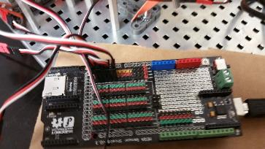The following images show the wired Arduino. Also featured is a copy of the code completed thus far.

int pot1 =0;

int pot2 =0;

int pot3 =0;

int pot4 =0;

int pot5 =0;

int p1= (pot1 - 512);

int p2= (pot2 - 512);

int p3= (pot3 - 512);

int p4= (pot4 - 512);

int p5= (pot5 - 512);

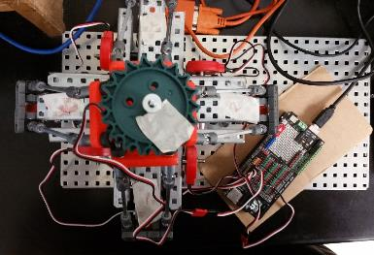

# Daily Log: 11/7/16

## Goals

Today, I hope to finish the coding process on my Arduino such that it receives the values from all the potentiometers and correctly interprets them. This will include coding the algorithms that determine the direction of the joystick. If I finish that, I will begin preparing my test robot.

## Accomplishments

Today, I did manage to get my program completed. I encountered some problems in getting accurate data from every sensor, because some of it seemed off to me. I was forced to realign some of the potentiometers, and it was also determined I had incorrectly wired at least one of the potentiometers. I corrected that issue, and everything began working alright. I recorded test values of all potentiometers to get a better idea of the ranges I would be working with. The Arduino serial monitor was properly formatted and reporting the values.

## Going Forward

The next step of my masterplan is completing getting the test robot working. The test robot consists of a holonomic drive bot with a lift. This will simulate the 5 degrees of motion of a drone. Fortunately, it is already constructed. All that I need to do is ensure it is wired to an Arduino, and then connected to the joystick.

## Images

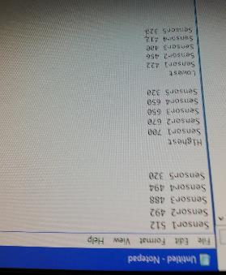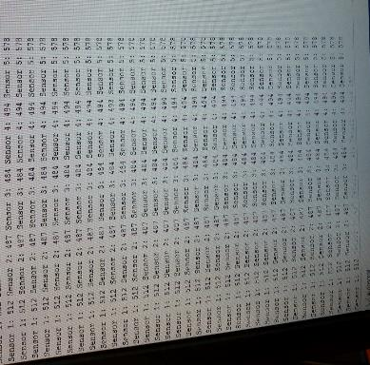The images show the screens displaying the serial output of the Arduino, as well as a text document I used to record max, min and position zero potentiometer values. Also included is the code.

### Code:

int pot1 =0;

int pot2 =0;

int pot3 =0;

int pot4 =0;

int pot5 =0;

int p1= (pot1 - 512);

int p2= (pot2 - 512);

int p3= (pot3 - 512);

int p4= (pot4 - 512);

int p5= (pot5 - 512);

int z = (p1+p2+p3+p4)/4;

int y = (p3+p4-p1-p2)/4;

int x = (p2+p3-p1-p4)/4;

int yaw = p5;

String in = "";

void setup() {

Serial.begin(9600);

}

void loop() {

pot1 = analogRead(A11);

pot2 = analogRead(A14);

pot3 = analogRead(A12);

pot4 = analogRead(A13);

pot5 = analogRead(A10);

int p1= (pot1 - 512);

int p2= (pot2 - 512);

int p3= (pot3 - 512);

int p4= (pot4 - 512);

int p5= (pot5 - 512);

int z = (p1+p2+p3+p4)/4;

int y = (p3+p4-p1-p2)/4;

int x = (p2+p3-p1-p4)/4;

int yaw = p5;

Serial.print("Sensor 1: ");

Serial.print(pot1);

Serial.print(" ");

Serial.print("Sensor 2: ");

Serial.print(pot2);

Serial.print(" ");

Serial.print("Sensor 3: ");

Serial.print(pot3);

Serial.print(" ");

Serial.print("Sensor 4: ");

Serial.print(pot4);

Serial.print(" ");

Serial.print("Sensor 5: ");

Serial.print(pot5);

Serial.print("Z Value: ");

Serial.print(z);

Serial.print(" ");

Serial.print("Y Value: ");

Serial.print(y);

Serial.print(" ");

Serial.print("X Value: ");

Serial.print(x);

Serial.println(" ");

}

# Daily Log: 11/9/16

## Goals

Today I want to make sure the test robot is functioning correctly, such that I can properly begin testing the joystick itself. This largely involves wiring the test robot, as it is already constructed. Once that is completed, I hope to begin working with wireless communication between the two Arduinos.

## Accomplishments

I did accomplish my goal of getting the test robot completed, however I worked slower than I thought I would. I did not get to the wireless communication segment. After wiring the robot, I glued the Arduino board onto a piece of cardboard so it would not be in contact with the metal. I did this using a hot glue gun, and it took me several tries to get a solid bond going that didn’t come apart when gently pulled (that was one of the main delays). I also put the XBee chip into the Arduino.

## Going Forward

Next class I plan to begin working with the software to create wireless communication between the robot and the joystick. I will be using XBee’s, which will take some time to learn. I expect the next few classes will be the most difficult yet.

## Images

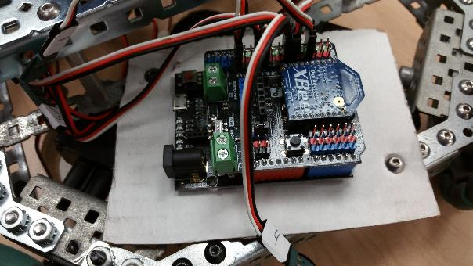Included are images of the wiring on the test robot, and some clear images of the robot itself.

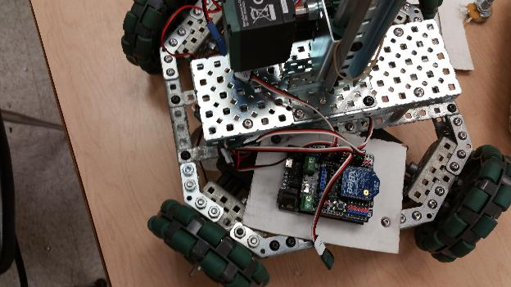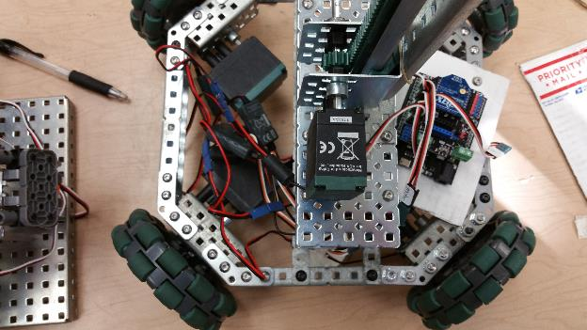

# Daily Log: 11/13/16

## Goals

My goals for today are to begin getting wireless communications established between the joystick and the robot. I will be getting the XBee’s installed and hopefully pairing them. I want to learn a bit more about the system, so I will be consulting some of my peers who have more experience on this subject than I do. I imagine this will take the whole class, but ideally, I would be programming the actual transmission today as well.

## Accomplishments

Today I was faced with a lot of setbacks. First, I could not get the XBee’s to pair with each other. There are a variety of reasons this might be, and it will require further investigation. I tried a variety of different cables, XBee’s and Arduino boards, and nothing was really working. By the end of the day some progress was made, and the XBee’s were both lighting up properly when plugged into their places on the Arduinos. I am theorizing this means the problem was with one (or both) the chips or boards themselves, and eventually the right combination of working parts was used.

## Looking Forward

Now that the problems I was having have seemingly been solved, I want to get these things communicating. That is probably easier said than done, but things are looking good. Next class I’ll hopefully be ready to start interpreting values on the end of the test robot.

## Images

Included is an image of XBee’s and their USB adaptors that were being used to test for pairing.

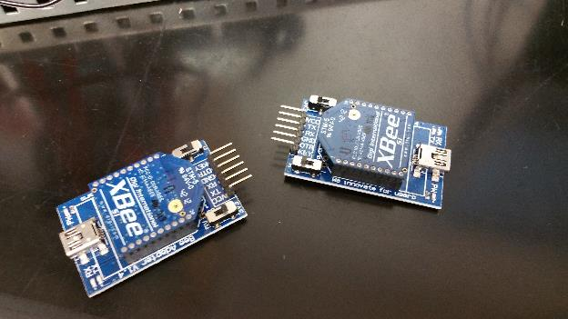

# Daily Log: 11/15/16

## Goals

My goal for today is getting the robot and the joystick communicating successfully, hopefully getting the values to at least serial print. Interpreting the values into movements will probably take more time, but if I can at least transmit the data then I will consider today a success.

## Accomplishments

Today, the XBee’s were successfully paired, again after some difficulty. However, data was successfully transmitted from XBee to XBee, as tested using the XCTU software. This is a huge step, and it should make the following steps much easier, especially now that we know the XBee’s are not the problem. I also completed the first draft of my code to send and receive data from both Arduino’s.

## Looking Forward

Now that the XBee’s are paired, the next step will be the Arduino transmission and coding that. I have the code currently, but I am not entirely confident it is correct. I need to test this code, and correct anything wrong with it. Then, I will begin testing the joystick.

## Images

Included is a screenshot of me pairing the XBee’s through XCTU. The data is being transmitted, and can be seen in the console log. Also, the latest versions of my codes are included

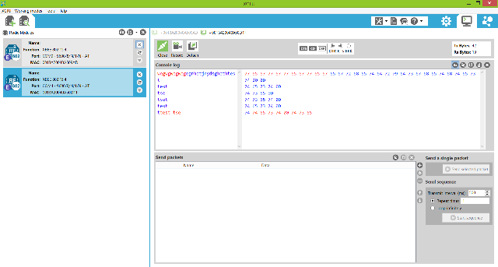

## Code on Joystick:

int pot1 =0;

int pot2 =0;

int pot3 =0;

int pot4 =0;

int pot5 =0;

int p1= (pot1 - 512);

int p2= (pot2 - 512);

int p3= (pot3 - 512);

int p4= (pot4 - 512);

int p5= (pot5 - 512);

int z = (p1+p2+p3+p4)/4;

int y = (p3+p4-p1-p2)/4;

int x = (p2+p3-p1-p4)/4;

int yaw = p5;

String in = "";

void setup() {

  // put your setup code here, to run once:

Serial.begin(9600);

Serial1.begin(9600);

}

void loop() {

  // put your main code here, to run repeatedly:

pot1 = analogRead(A11);

pot2 = analogRead(A14);

pot3 = analogRead(A12);

pot4 = analogRead(A13);

pot5 = analogRead(A10);

int p1= (pot1 - 512);

int p2= (pot2 - 512);

int p3= (pot3 - 512);

int p4= (pot4 - 512);

int p5= (pot5 - 512);

int z = (p1+p2+p3+p4)/4;

int y = (p3+p4-p1-p2)/4;

int x = (p2+p3-p1-p4)/4;

int yaw = p5;

if(Serial1.available() > 0 ){

  in = Serial1.readStringUntil('\n');

  Serial.print(in);

}

Serial1.println(z);

delay(100);

/*Serial.print("Sensor 1: ");

Serial.print(pot1);

Serial.print(" ");

Serial.print("Sensor 2: ");

Serial.print(pot2);

Serial.print(" ");

Serial.print("Sensor 3: ");

Serial.print(pot3);

Serial.print(" ");

Serial.print("Sensor 4: ");

Serial.print(pot4);

Serial.print(" ");

Serial.print("Sensor 5: ");

Serial.print(pot5);

Serial.print("Z Value: ");

Serial.print(z);

Serial.print(" ");

Serial.print("Y Value: ");

Serial.print(y);

Serial.print(" ");

Serial.print("X Value: ");

Serial.print(x);

Serial.println(" ");*/

}

## Code for receiving:

String in = "";

void setup() {

  // put your setup code here, to run once:

Serial.begin(9600);

Serial1.begin(9600);

}

void loop() {

  // put your main code here, to run repeatedly:

if(Serial1.available() > 0 ){

  in = Serial1.readStringUntil('\n');

  Serial.print(in);

}

}

# Daily Log: 11/28/16

## Goals

My goal for today is to complete the process of sending data wirelessly to my test robot. I want to successfully transmit that data and interpret it today. That means I will need to add that section to my code. I will also hopefully be ready to move onto the drone by the end of this class.

## Accomplishments

Today, though I didn’t meet my goals, I made some important progress. For the first time, I turned on the Arduino and test robot. The lift began running and I could not stop it. After some troubleshooting and help, I managed to determine it was an error with the power source, so I began using a new power cable. After that, everything was working on the up and up. I also tested both of my codes, and though they were successfully compiled, the data was not transmitting. Again, this is delaying my progress. I continued to troubleshoot, reconfirmed that the XBee’s were paired, and eventually stopped work for the day.

## Looking Forward

I will continue to research possible errors moving forward, as well as properly created codes to look to as examples. I think I am very close to completion of this phase of the project, and though there have been a frustrating number of glitches (or perhaps user errors), I am very optimistic about the projected timeline from this point forward.

## Images

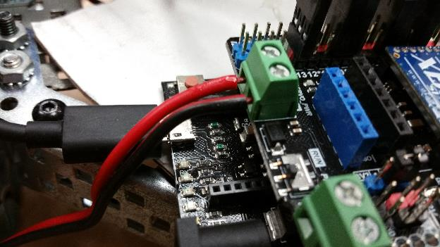I have included images of the new power cable I am using, attached to the robot.

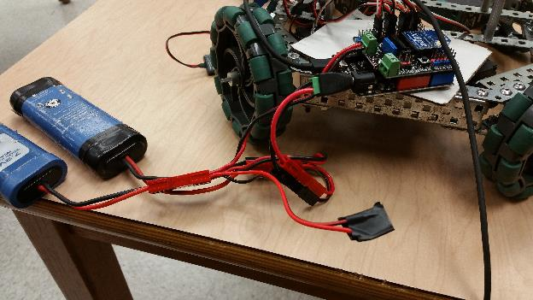

# Daily Log: 1/24/17

## Goals

My goals for today are to begin the process of getting the potentiometers properly wired. After the failure of my attempts at crimping, today will hopefully bring a solution to the problem. I might have to redo the crimping, or find a new solution. For now, the transfer of data will placed on the backburner, as I have come to an impasse on it.

## Accomplishments

Today I found a solution to the problem at hand, which is to replace the badly crimped wires with servo wires. This will simply the process significantly, as I will only need to remove the old wires and solder on these new ones to the potentiometer. I began that process today, completing the first of the potentiometers.

## Looking Forward

The next step is going to be finishing the soldering. After the next three potentiometers, I will attempt to finalize the construction of the finished product, and get the Arduino up and running. This will bring me back to the wireless communication, which is going to be another hurdle.

## Images

Included is an image of one of the potentiometers soldered to the incorrectly crimped wires. Removing these wires was the first step of today. Also included is an image of the soldering process.

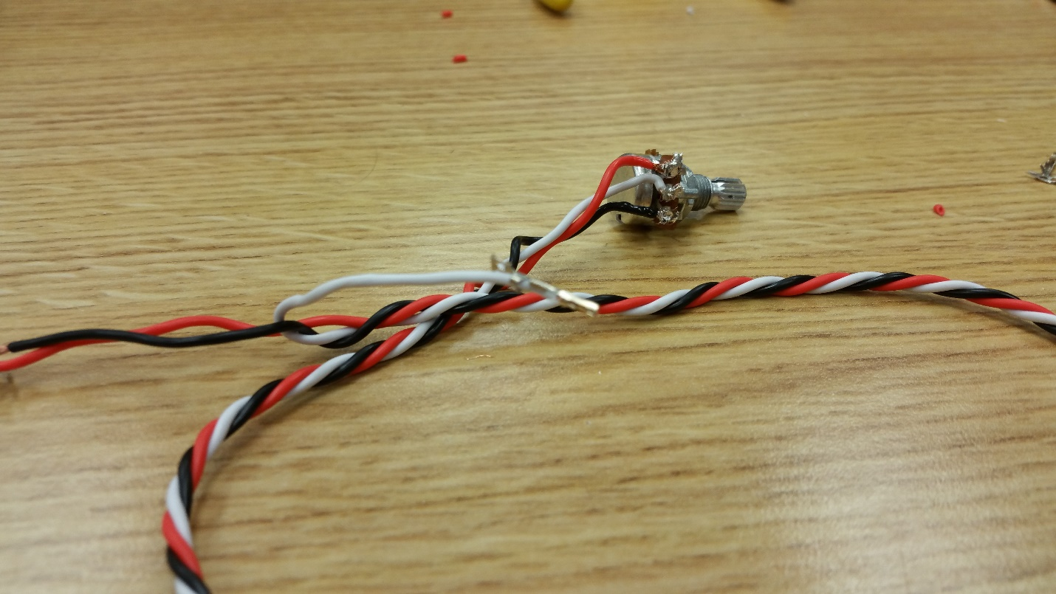

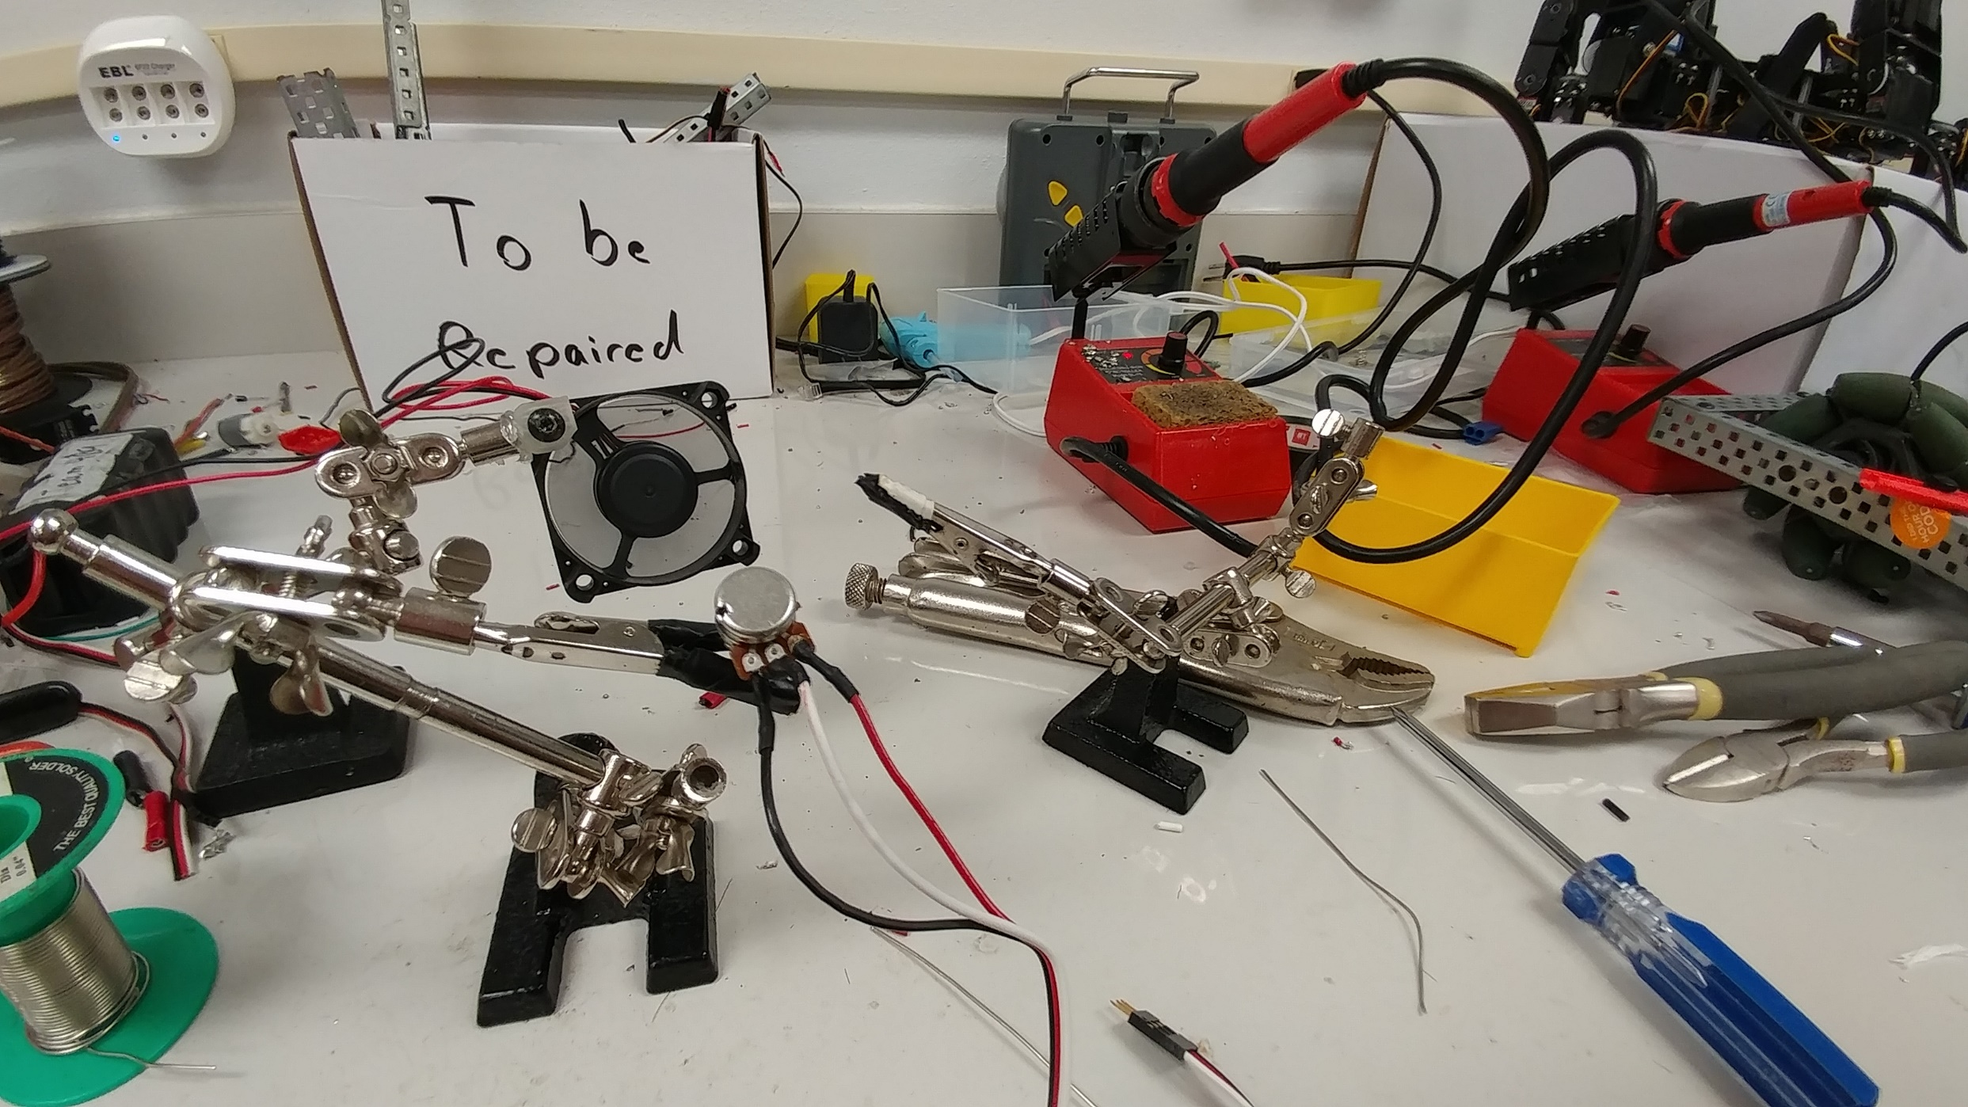

# Daily Log: 1/26/17

## Goals

My goals for today are to complete the soldering of the wires to the potentiometer. Ideally, I would finish that task and begin the assembly of the final product, but realistically I doubt I will get to that point.

## Accomplishments

I did successfully finish the soldering of all the potentiometers. They are now wired, such that they can easily be plugged in and out of any Arduino board. As expected, I did not get to the point of installing the potentiometers, though I did already have one in, but not calibrated.

## Looking Forward

As said, going forward I will need to begin the assembly of the final product. However, before I do that, I might simply install the potentiometers and calibrate them. I will also need to test them and ensure none were damaged by the soldering process. If there are any problems, I will want to sort them out before I get the whole rig put together.

## Images

Included is an image of me removing the bad wires on one of the potentiometers resting in its frame, as well as a close up of a completed potentiometer.

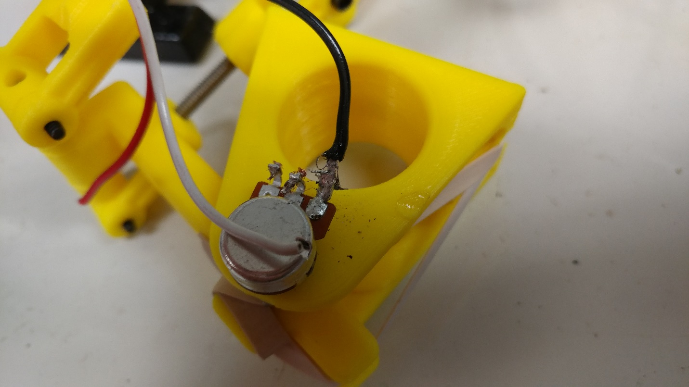

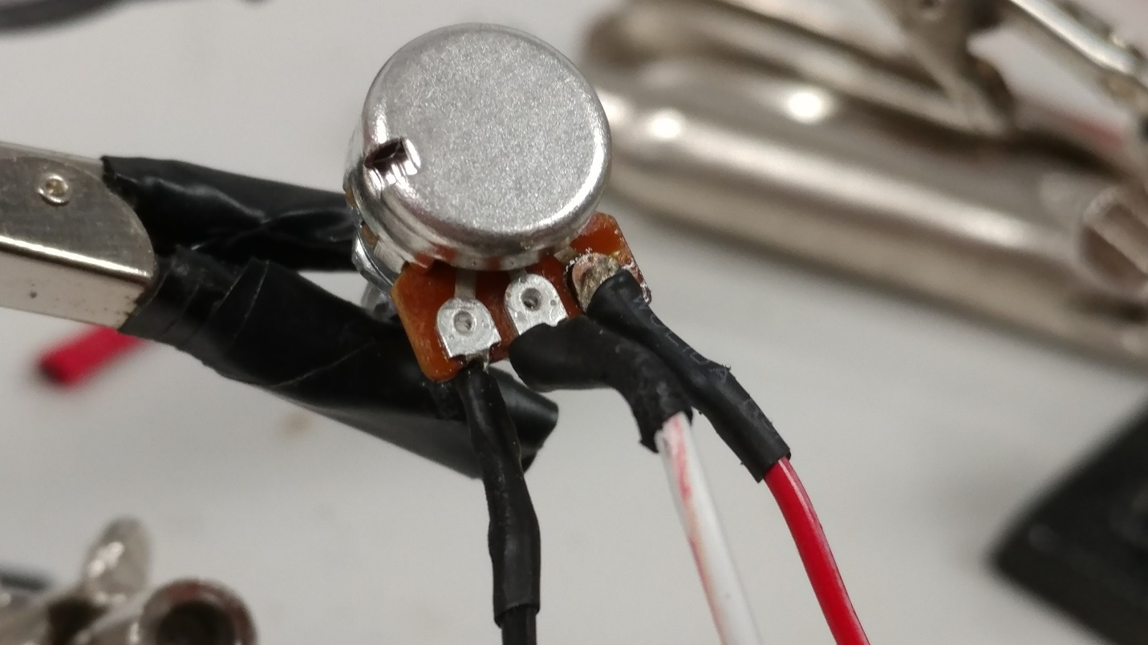

# Daily Log: 2/9/17

## Goals

My goals for today are to begin the process of mounting the components onto the base. From there, I will need to mount rubber bands and the rest of the assembly onto each part. I also need to finish indexing potentiometers.

## Accomplishments

I successfully began mounting the bases of arms, I completed 2 of those. But more significantly, all of the potentiometers should finally be indexed and soldered correctly. That means, going forward, I will strictly be assembling ready parts, which should speed up the process significantly. I also did a bit more sanding and cleaning up on some of the parts. One of the potentiometers would not stick well in the arm, so I ended up using some hot glue to correct that issue.

## Looking Forward

The next step is going to be simply attaching the 2 remaining bases. From there, I will need to attach those to the main assembly. That will include some construction, but not too much. I expect it will take only one more class to finish, maybe two if things don’t go as planned.

## Images

Included is an image of one of the base components mounted to a metal sheet base. Also, one of the potentiometers indexed and fixed into its place in that same base component.

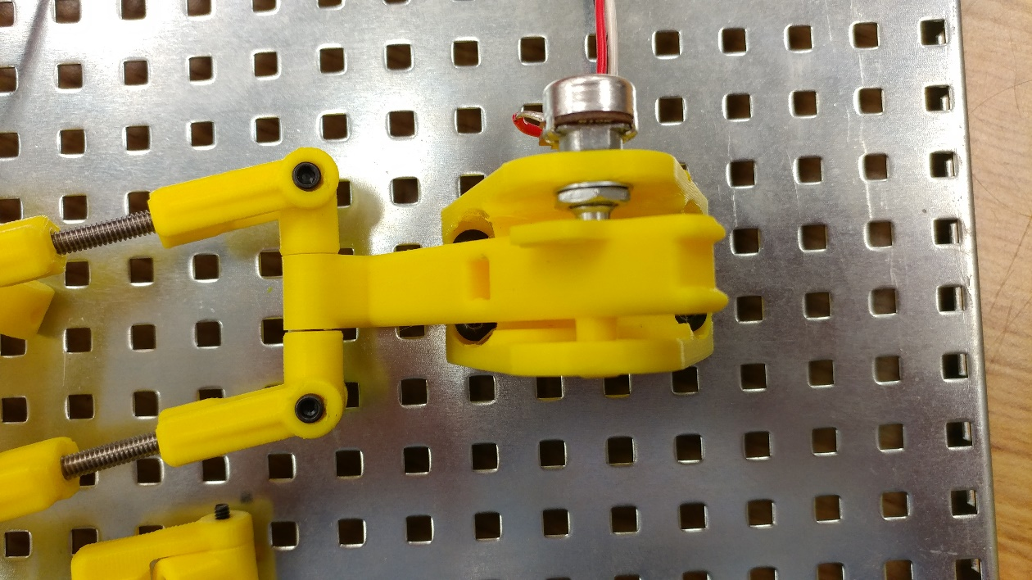

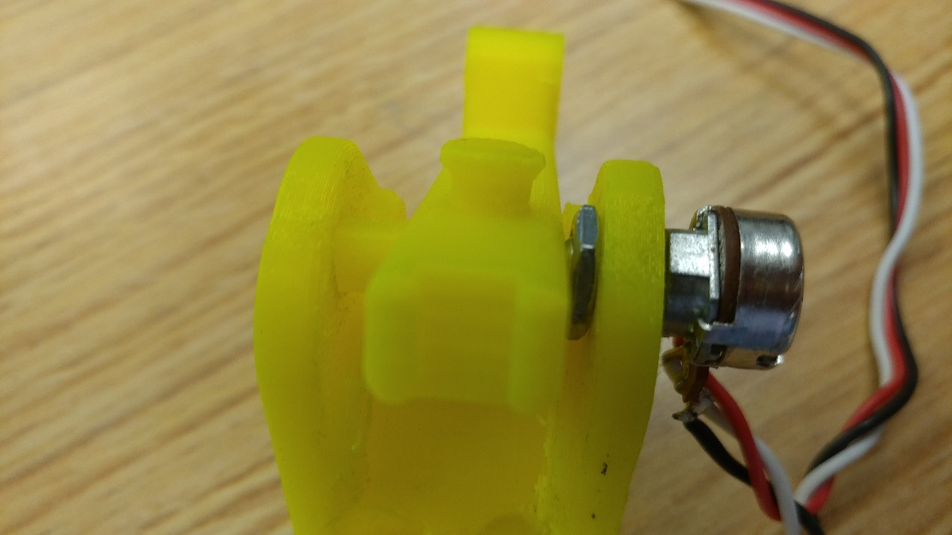

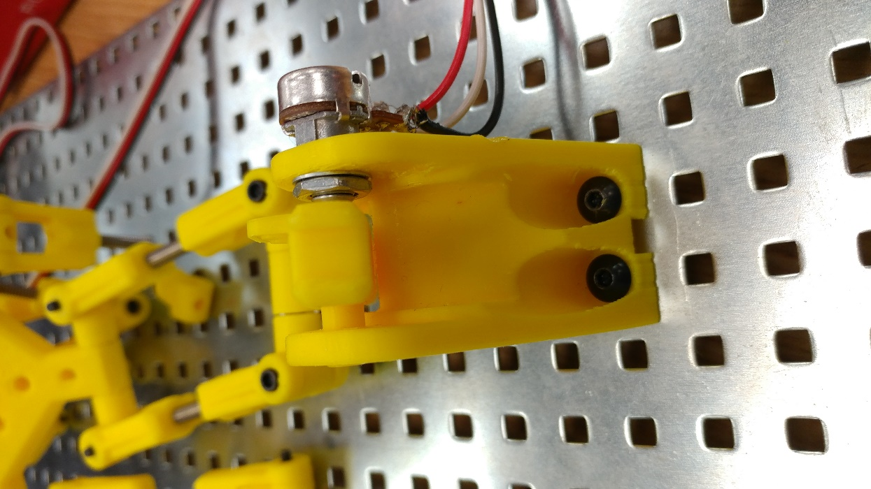

# Daily Log: 2/15/17

Goals for the week:

This week, ideally I will get my joystick completed and ready to attach to an Arduino. That is my primary goal. Not much is left on this, so it is manageable. The secondary goal I have for this week is 3D printing a joystick grip, that will also be used to rotate the drone. I will need to design this, and if I can get a prototype printed before the end of the week that would be great.

What I achieved:

Fortunately, I had a pretty successful week. The 3D Joystick is complete, with the exception of a single arm for which I need to 3D print a replacement component. Correcting it will take only a minute or two, and than it will be ready to test with the Arduino. I ran into some complications, as the potentiometers were not sticking as designed into their mounts. I corrected the issue with some hot glue. Aside from that, I also managed to prototype the grip I wanted, and begin the 3D print.

Looking Forward:

The next step I need to take is ensuring that the values the joystick is giving me are workable by the Arduino. Once that is confirmed, the device will basically be complete. This might take some time, depending on the issues I run into. Additionally, I want to continue work with the grip I have, which may or may not be how I would like it to be in the end. I imagine it will take at least 2 more prints to get it right, but this isn’t a huge priority right now so I should be all right. Finally, as the project approaches its end stages, I would like to start considering other features that can be added to improve ergonomics and make the joystick have as many functionalities as it would be useful to have.

Images:

The images below show the hot glue work I used to secure one of the potentiometers, as well as the beginning of the 3D print. Finally, there is a 2D image of the grip I am printing.

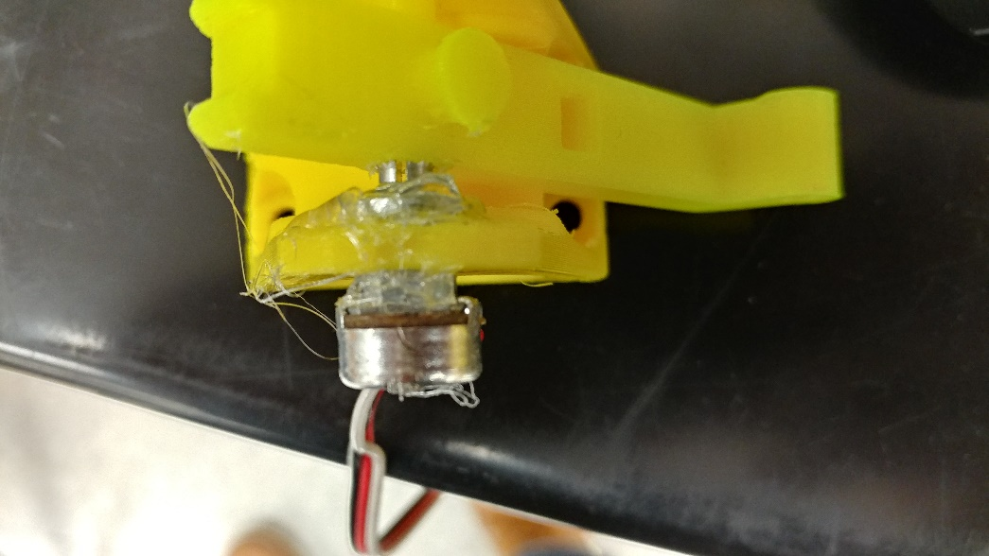

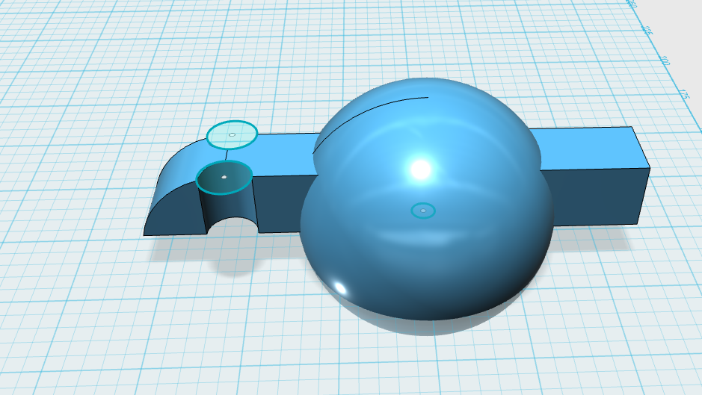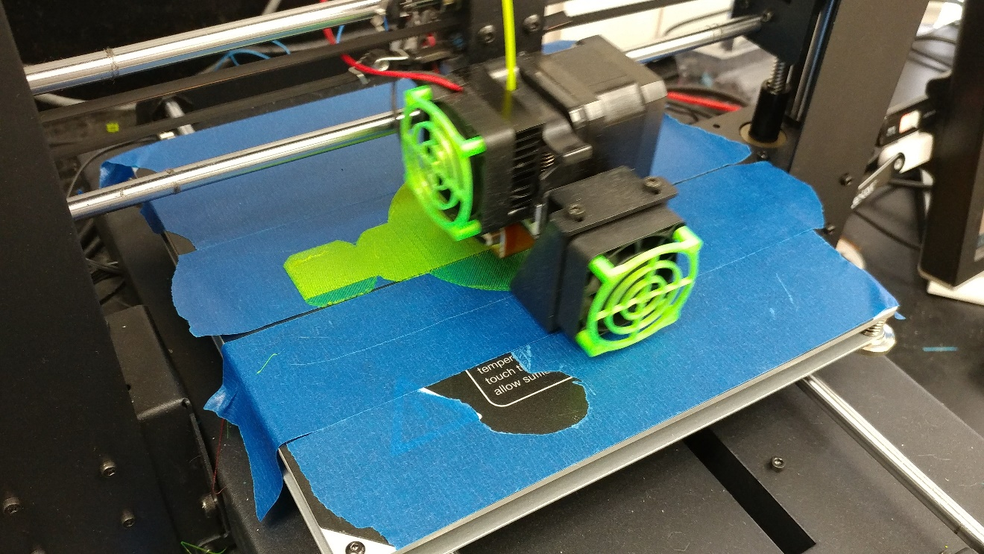

# Daily Log: 2/24/17

## Goals

My goals for today are to complete the assembly of the 3D joystick, examine my 3D printed grip for errors, and go from there. If needed, I may begin a new print. Otherwise, I may begin the mounting process.

## Accomplishments

Today was very productive. After examining my 3D printed grip, it was determined that I should keep it as is. It was discovered that the object had printed with a solid fill, which makes it extraordinarily heavy. This works in my favor, as the joystick has tended to sit a bit too high, but the weight will bring it down. After that, it was also determined that the hole I had built in for the potentiometer axel was too large. After some prototyping, I constructed a design that relies on two drilled holes and a mount. The grip preliminarily mounted for now. Finalizing that will be the final step of the building of the project.

## Looking Forward

I need to finalize the attachment of the grip to the top of the joystick. This will mean putting on a locknut, and should be very simple and quick. Otherwise, I also may need to adjust the rubber bands on some of the arms. Then, I will be on to programming.

## Images

Included are two images of the attached grip.

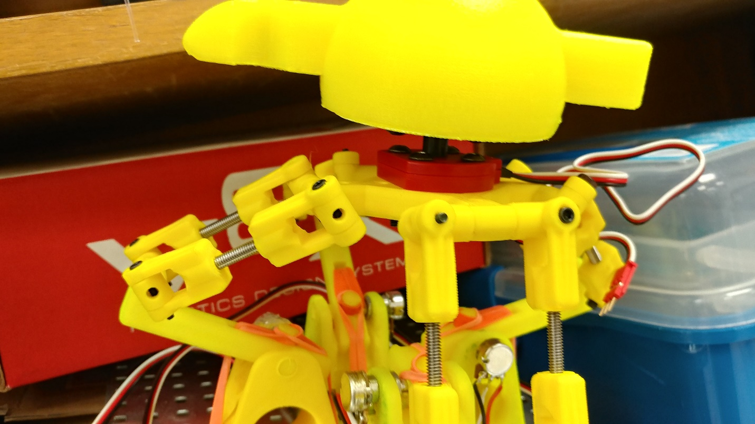

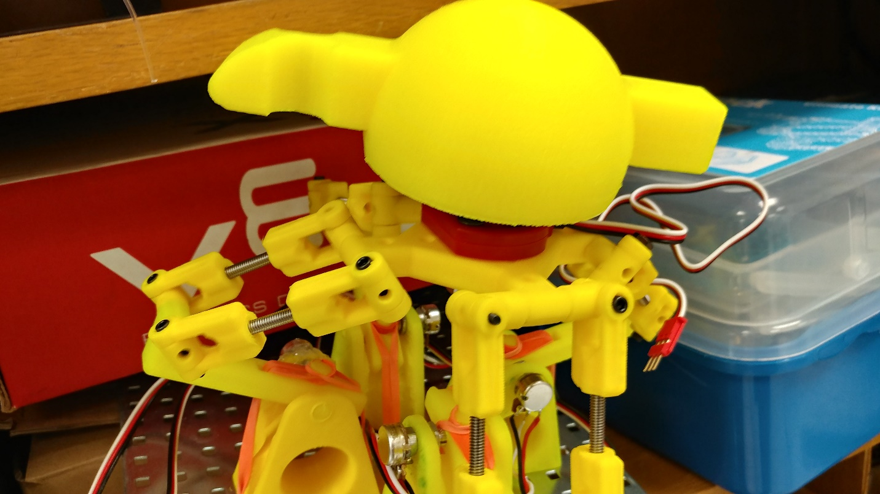

# Daily Log: 2/28/17

## Goals

My goals for today are to finally attach the grip and complete the building of the joystick. This might include adjusting the rubber bands and arm lengths, but otherwise it should be fairly straightforward. I am considering a reprint of the grip, with an altered design.

## Accomplishments

Today I ended up accomplishing to major things. First, I got the arms of the joystick calibrated to what they needed to be. The two joints needed to be a specific length apart, and I have accomplished that much. This should help with the accuracy of the joystick. I also began the redesign and then print of a second grip. This one is improved to be more ergonomic, and mounting it should be much easier.

## Looking Forward

Once the print of the new grip completes, I will mount it. The only other remaining physical job is to experiment with the rubber bands until the joystick is working well. Then, assuming no more unexpected changes or errors arise, I will be done. Of course, once the joystick is attached to an Arduino and I can start looking at values, changes may need to be made to the physical joystick, but those changes are mostly going to be minor, if they exist at all.

## Images

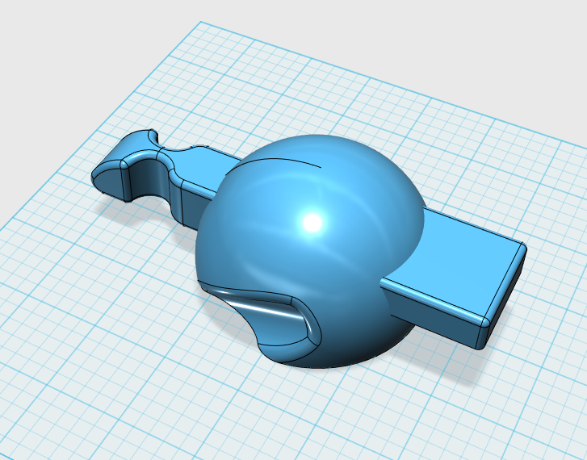Included is an image of the 3D model of the new grip. Also, the process for measuring the arms is shown in a second photograph.

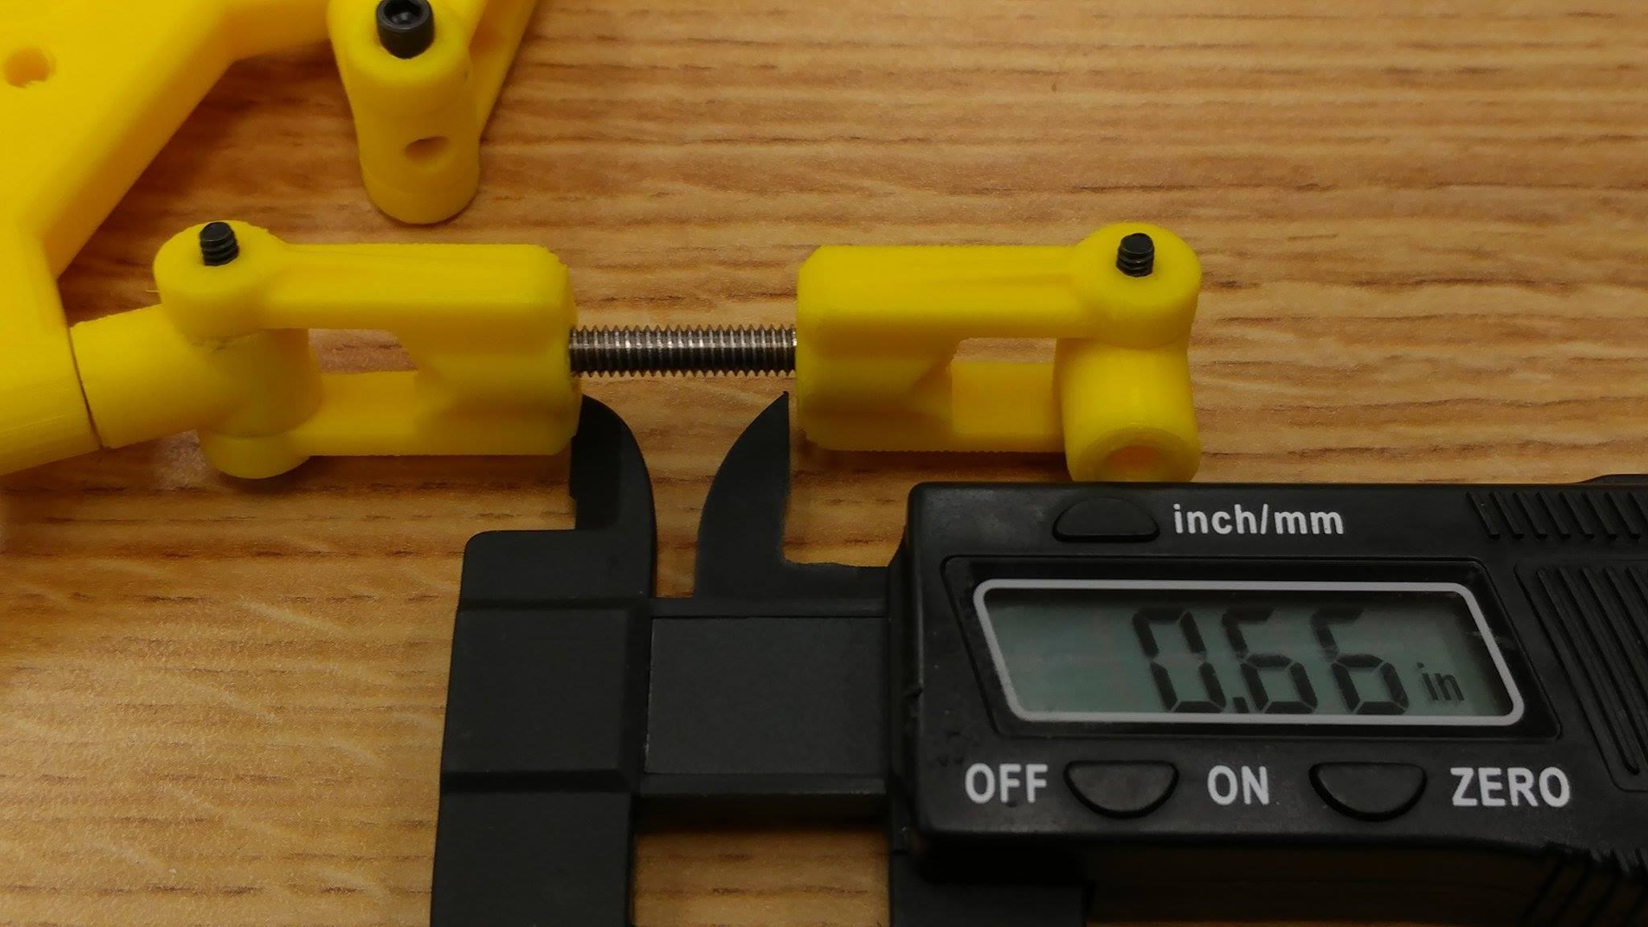

# Daily Log: 3/2/17

## Goals

My goals for today are to complete the construction of the 3D joystick. This will include calibrating the rubber bands as well as mounting the grip, in a permanent and final way.

## Accomplishments

The grip that was printed came out well, though one of the holes on the bottom for mounting was not as well placed as I had hoped. I had to do some rough carving into the bottom of the print to make a place for the screw, but otherwise it looks great. Using some hot glue to ensure that the mounting mechanism remains in place, I successfully used a flat bearing and axel collar as a method of connecting the grip to the joystick. The rubber bands I didn’t get done, unfortunately, as I had a few break on me which slowed down my progress. The grip also took longer than I thought, so I ended up not completed my goal of finishing the calibration of the bands.

## Looking Forward

Finishing the rubber bands is the only task I need to accomplish before I move back into the transfer of data and Arduino issues. So, that will be my goal next class.

## Images

Included are three images of the printed 2nd grip

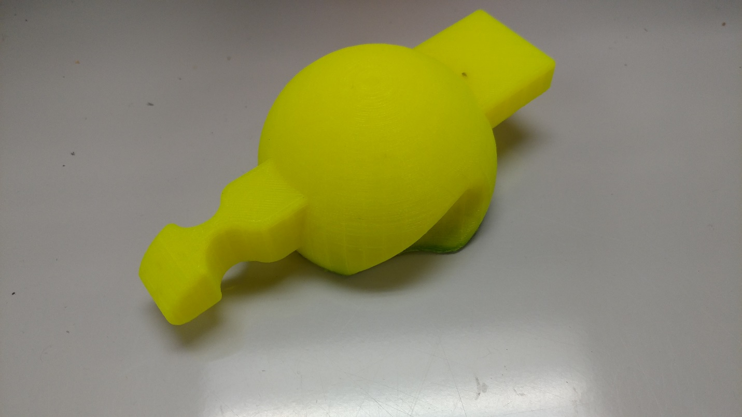

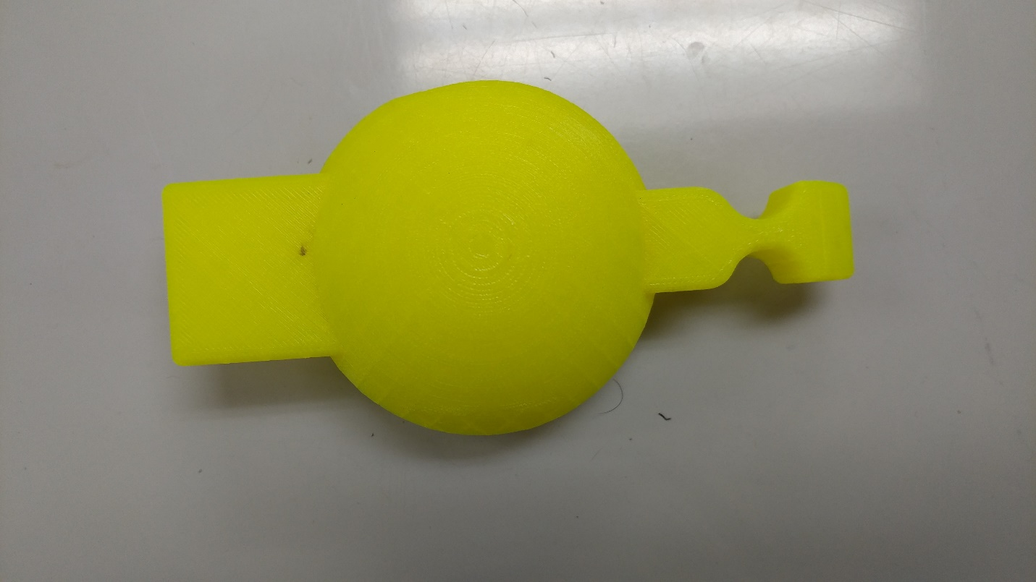

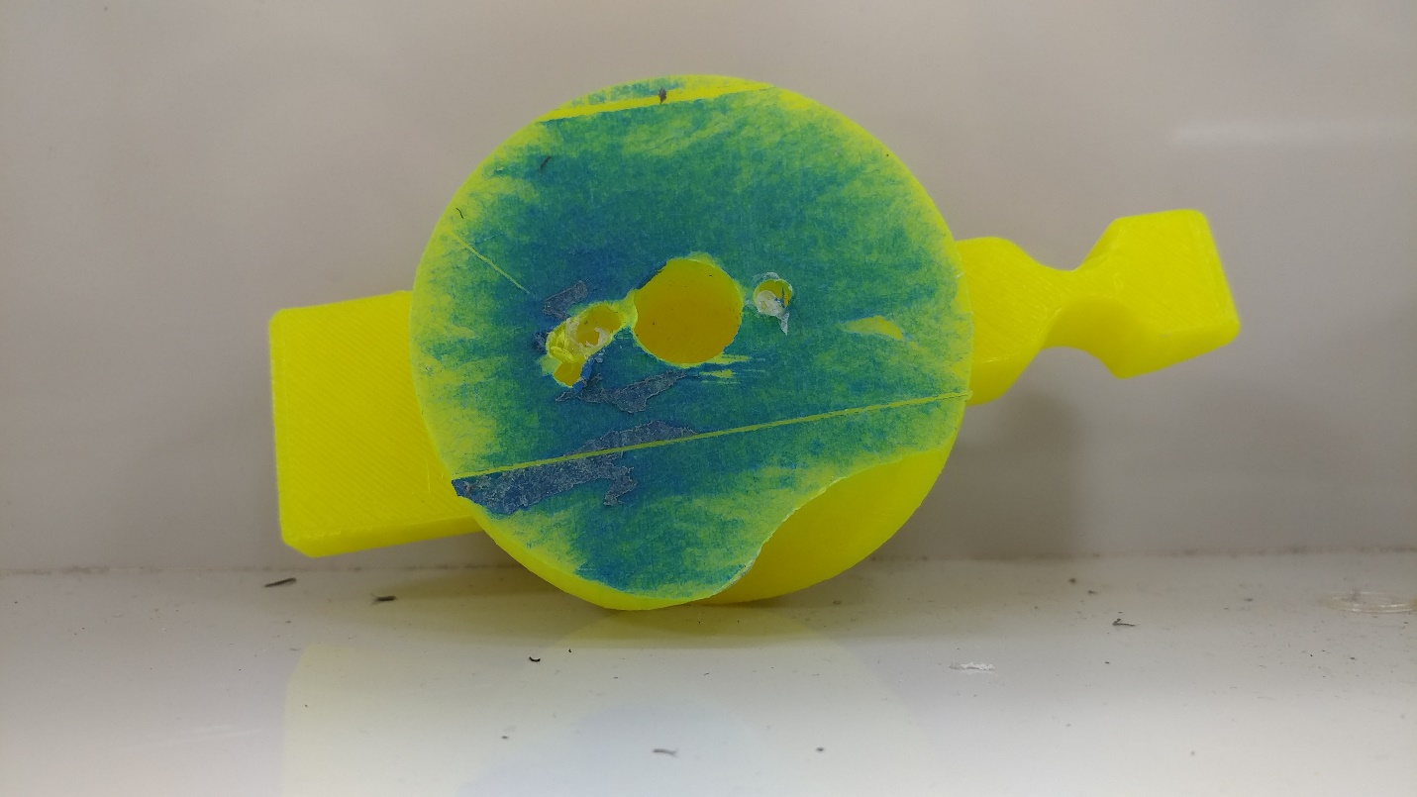

# Daily Log: 3/6/17

## Goals

My goals for today are to complete the mounting of the top of the joystick (the mounting completed last time broke off) and the calibration of the rubber bands.

## Accomplishments

Both tasks were accomplished. The top knob of the joystick is now firmly fixed in place, and the rubber bands were calibrated such that the resting position of the joystick, when released from any other location, is directly in the center of all its degrees of motion. I developed a technique for dealing with the rubber bands quickly (using an Allen wrench to pull rubber bands through), so if they do snap in the future there should be much less of an issue.

## Looking Forward

Now that the joystick is done, the key is going to be getting values on the Arduino. From there, it will be a matter of tweaking the joystick for maximum accuracy and then finding an efficient and accurate method of interpreting those values.

## Images

Included are images of the completed joystick.

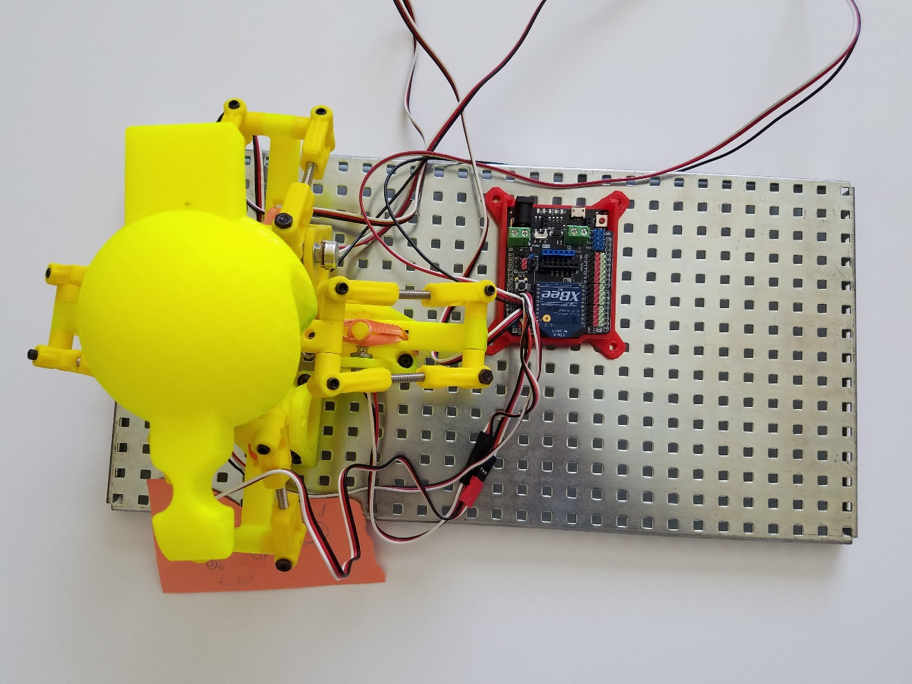



# Daily Log: 3/14/17

## Goals

Today I am going to begin readdressing the various programming issues encountered earlier in the build. I will be working with a peer with more experience working with Arduino, which will hopefully allow us to successfully get the joystick transmitting data.

## Accomplishments

Today, we began the programming process, and we had a decent head start because my peer has existing code for transmitting values wirelessly. So, we began the process of verifying that the values being reported were accurate, and correcting when need be. For example, the resting position Pot1 is 76 above its middle position, so the read value of the Pot1 is decreased by 76 before being processed.

## Looking Forward

The joystick is now giving out usable data, so the next step is going to be transmitting and processing the transmitted data.

## Images

Included are snippits of the code and the setup used to complete this task.

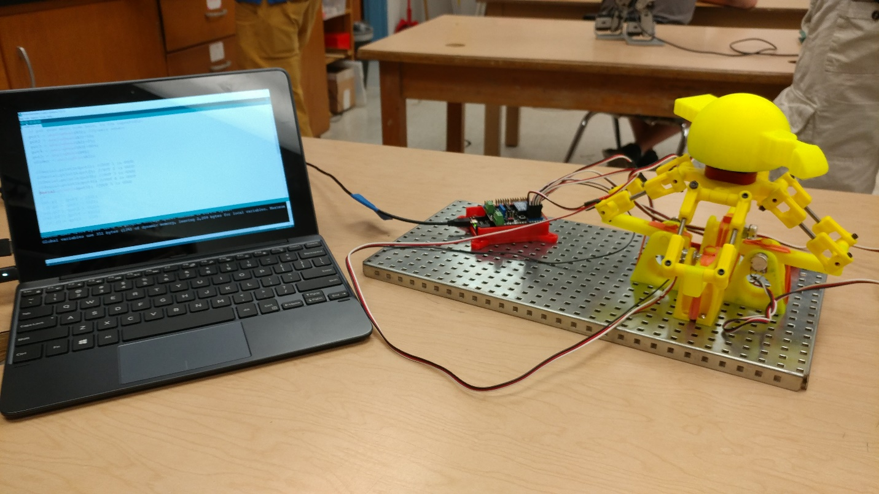

pot1 = analogRead(A0)-76; //sensor 1

pot2 = analogRead(A1)+300;//sensor 2

pot3 = analogRead(A2)-221;//sensor 3

pot4 = analogRead(A3);//sensor 4

pot5 = analogRead(A4);//sensor 5

slider = analogRead(A5);

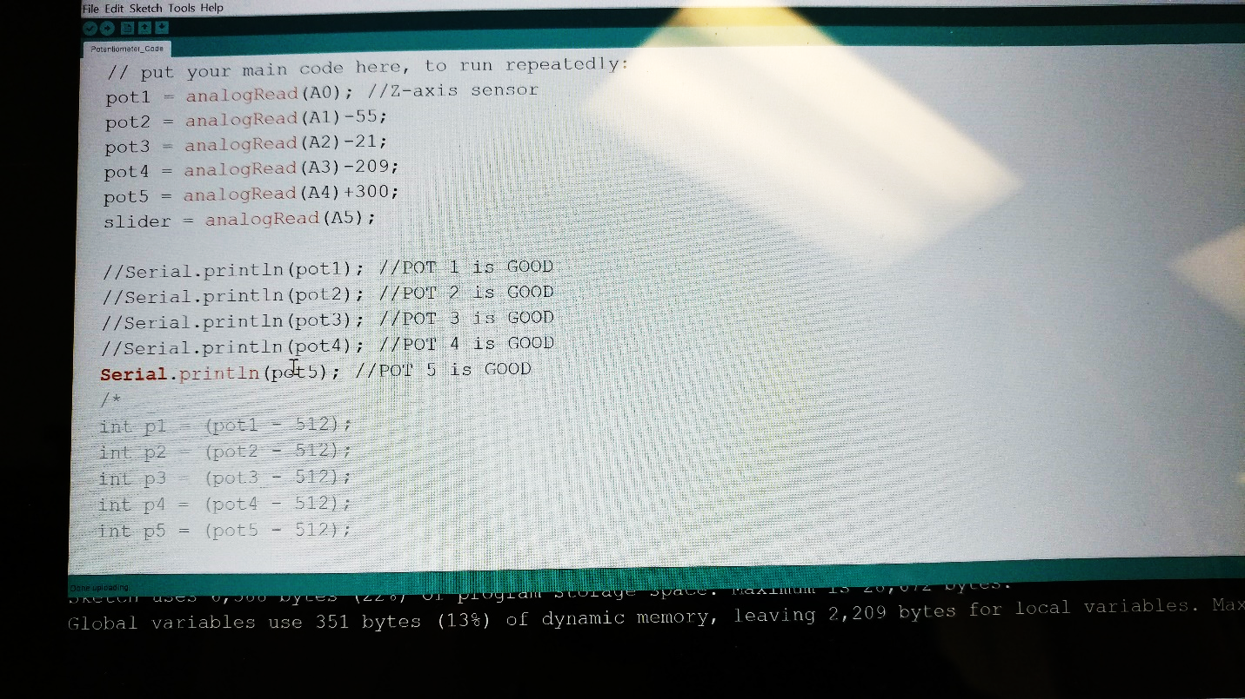

# Daily Log: 4/7/17

## Goals

The goal for today is to transmit the data from the joystick to the Arduino which is attached to the test vehicle. This is the step that really stalled all progress previously, so hopefully this can be handled fairly quickly. If we get past that step, we will attempt to begin interpreting the data. This should be easier, as this step has been planned for since the beginning.

## Accomplishments

Today we did finally transmit data across Arduinos, wirelessly. Code was written, such that when the Arduino Mega (which is mounted on the test vehicle), the values are analyzed and a string is printed which indicates whether the value is sufficient for movement. This is largely a proof of concept step, showing that values can be transmitted and interpreted at a reasonable rate, but it is an important one.

## Looking Forward

As data can finally be transmitted, next class will be spent implementing the code that will allow the Arduino Mega on the test vehicle to react to data that is being sent. This might involve some testing and prototyping.

## Images

Included are screenshots of the code, and data that has been sent wirelessly from the joystick. The second image is the transmitting code.

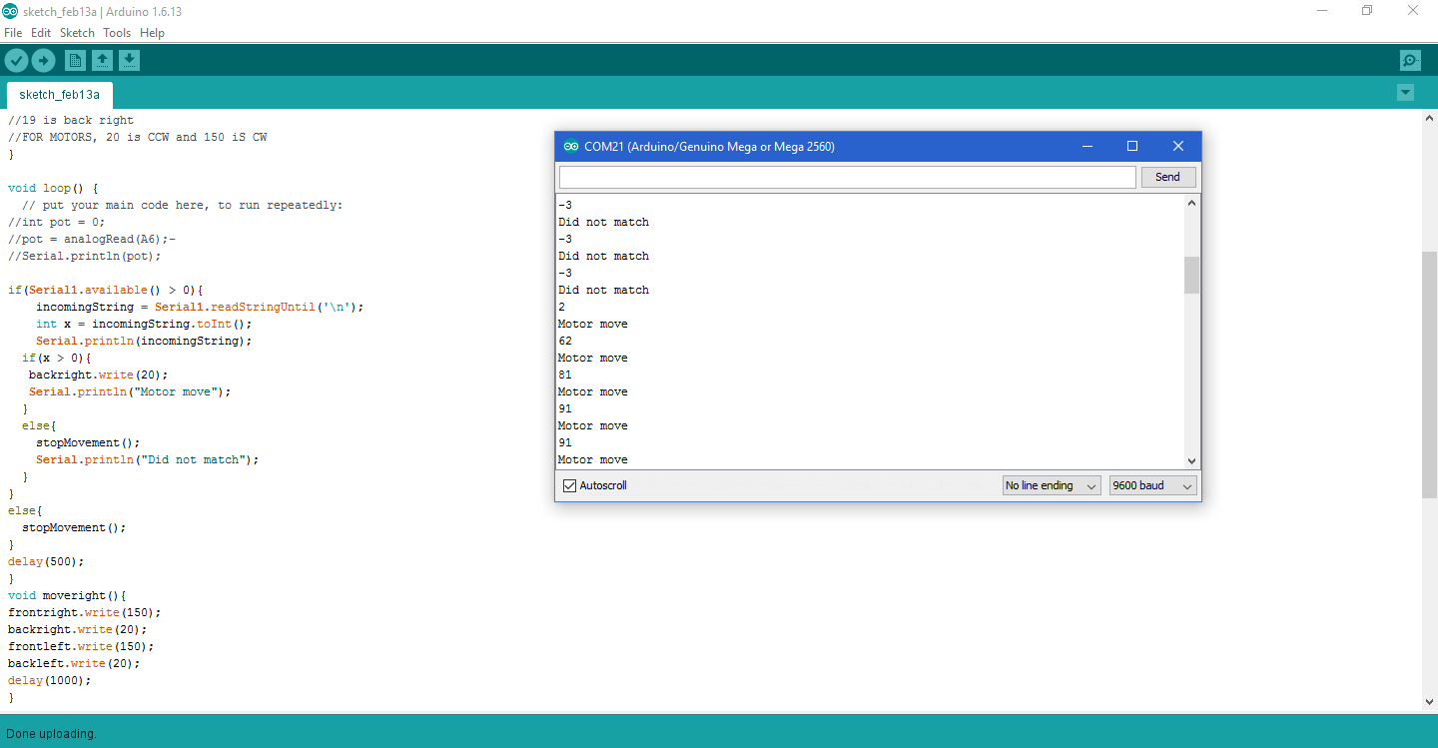

# Daily Log: 4/21/17

## Goals

The goal for today is to full interpret the data being sent to the test vehicle, with the goal in mind of actually getting it to respond. This will involve testing different methods, and possibly reconfiguring transmitting settings, if need be.

## Accomplishments

Significant progress was made today. The first thing that was addressed was the development of a tentative plan moving forward. Rather than actually directly interpreting the data, what we will is have 4 set movement patterns in each of the cardinal directions. These will be activated by the transmitted value, triggering a set method that moves the vehicle. We tested the vehicle to determine the needed motor speeds for each direction, and added the code for each of these methods. The vehicle was responding to these movements, but we encountered some difficulty with timing.

## Looking Forward

We hope to get this method of control finished in the upcoming class periods, which should not take long. Following that, the goal is to begin implementing the Joystick in such a manner that the test vehicle is interpreting the values as a whole, not simply moving in accordance to methods. For instance, we want the vehicle to be able to move diagonally.

## Images

Included are screenshots of 2 of the methods being used, as well as the implementation of them.

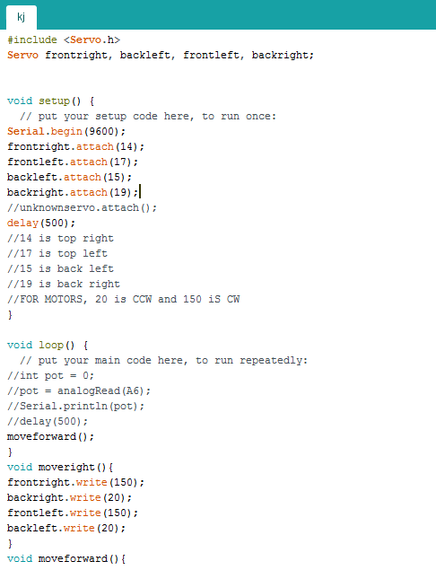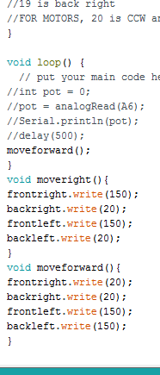

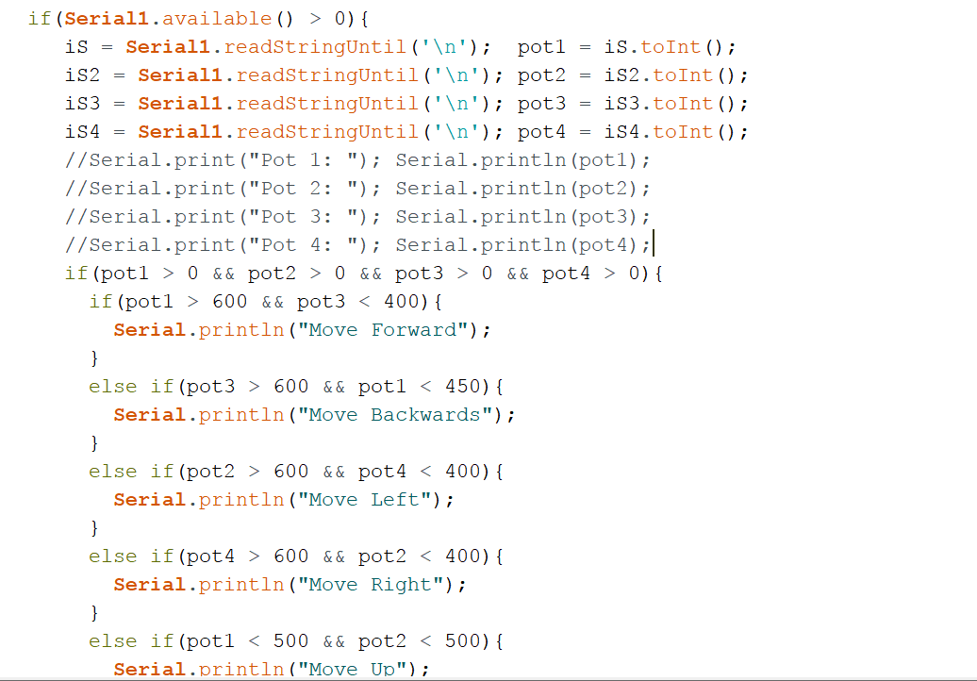

# Daily Log: 5/2/17

## Goals

The goal for today is to complete the project to the fullest extent possible. Time constraints are likely going to limit the development of full holonomic drive utilizing the joystick, but the 4 cardinal directions, as well as the lift, will hopefully be completed by today.

## Accomplishments

The goal of the day has been accomplished, with the vehicle fully responding to the movement of the joystick. The movement is a bit jumpy, and sometimes laggy, but these issues are insignificant and could likely be addressed in any future extension of this project rather quickly.

## Looking Forward

Looking forward, if work is to be continued on this project, the main extension would have to be a development of full holonomic drive. Beyond that, expanding the joystick to use with a drone would be an exciting and possible development, as well.

## Images

Included is a screenshot of the new code for the vertical lift.

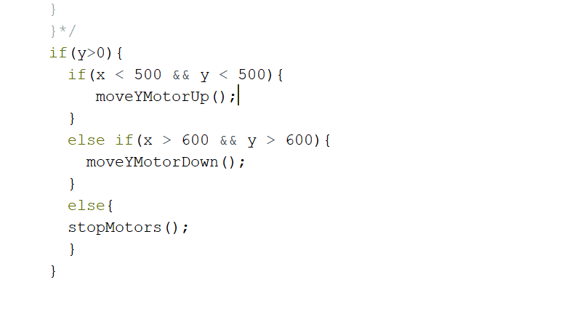

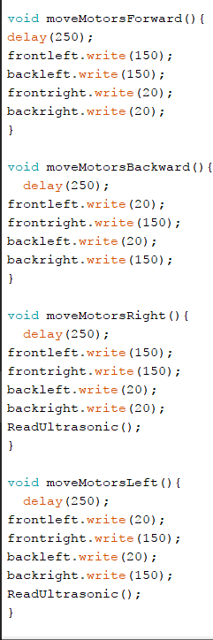

# Final Images

# https://dl2.pushbulletusercontent.com/qAEHAEf8IavhowNhhI5lIVzdobfnNuW0/20170507_142019.jpg

An overhead view of the 3D Joystick and the plate it is mounted on.



A side view of the Joystick

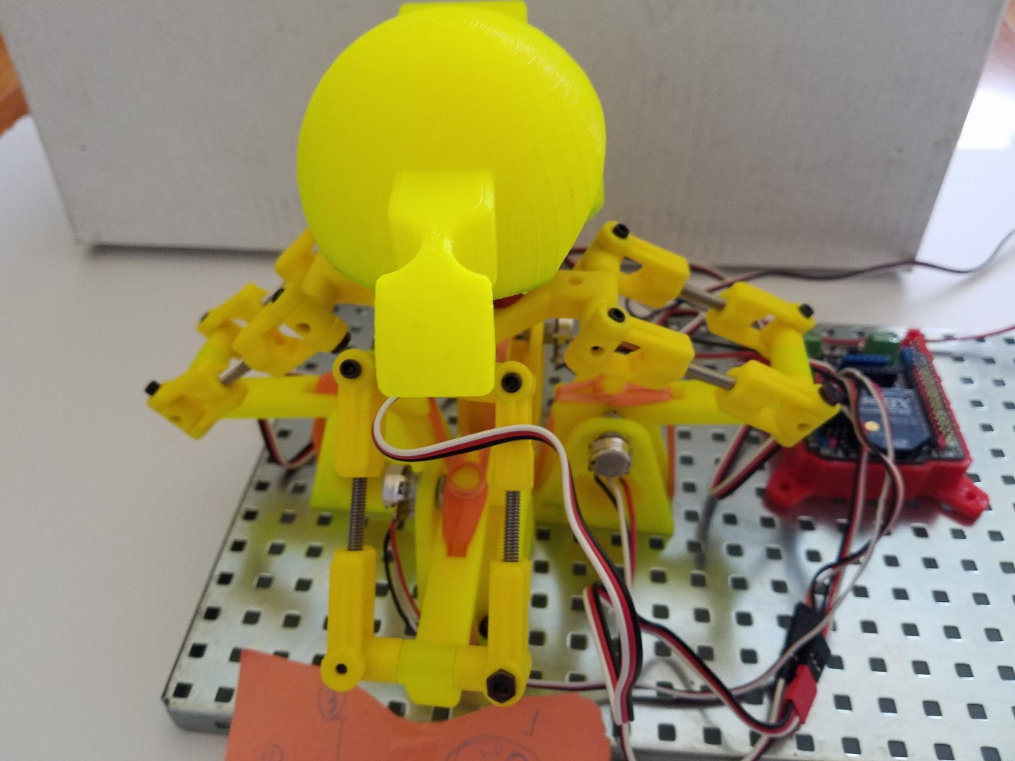

A front view of the 3D Joystick

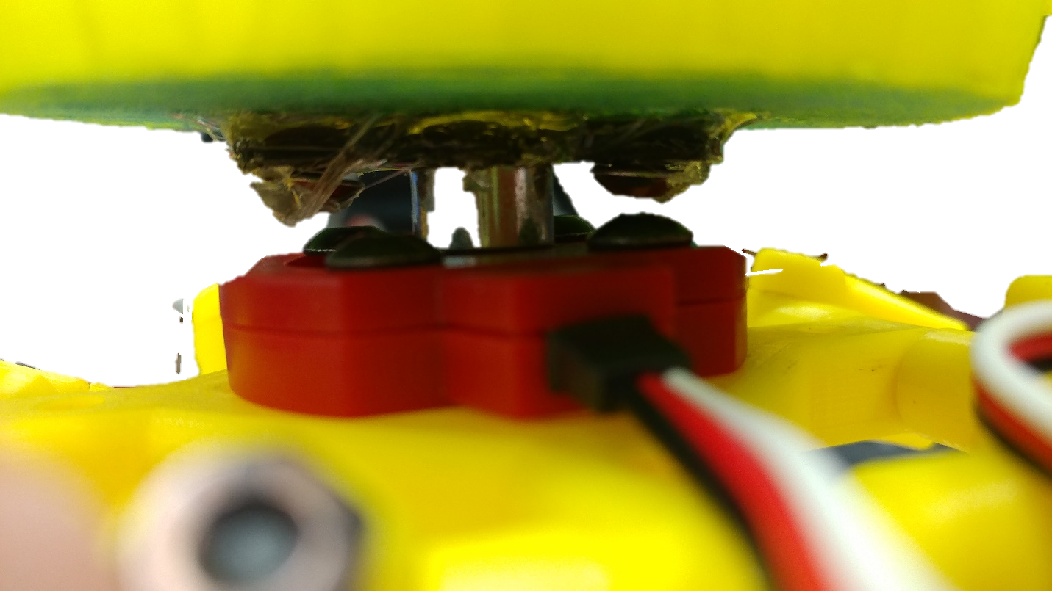

A close view of the knob mounted on the top of the joystick

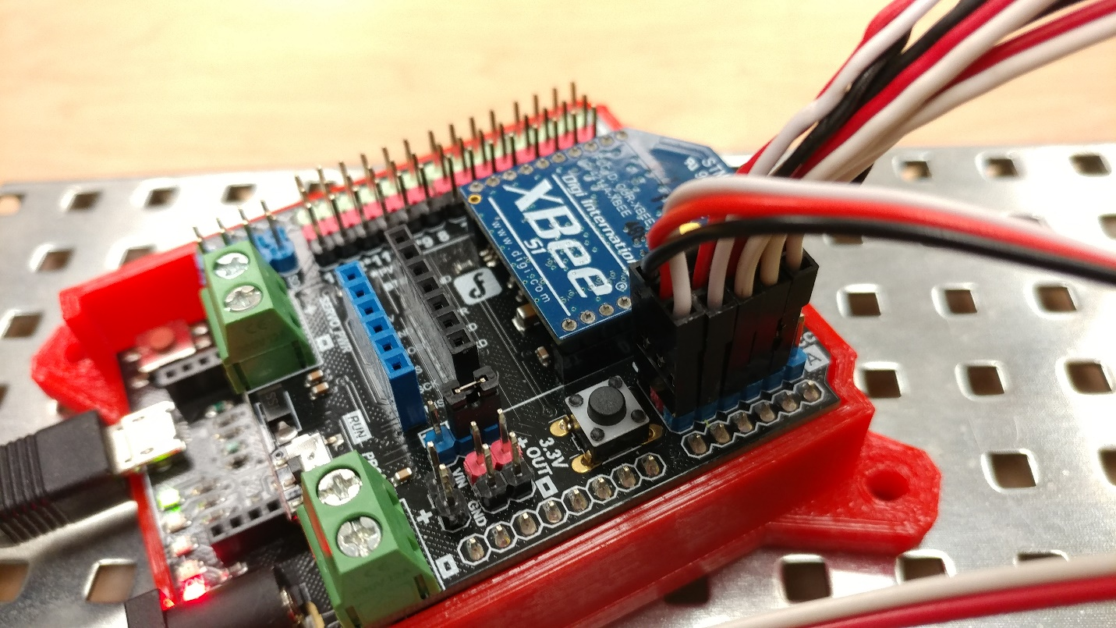

A close view of the Arduino connected to the joystick, with potentiometers plugged in

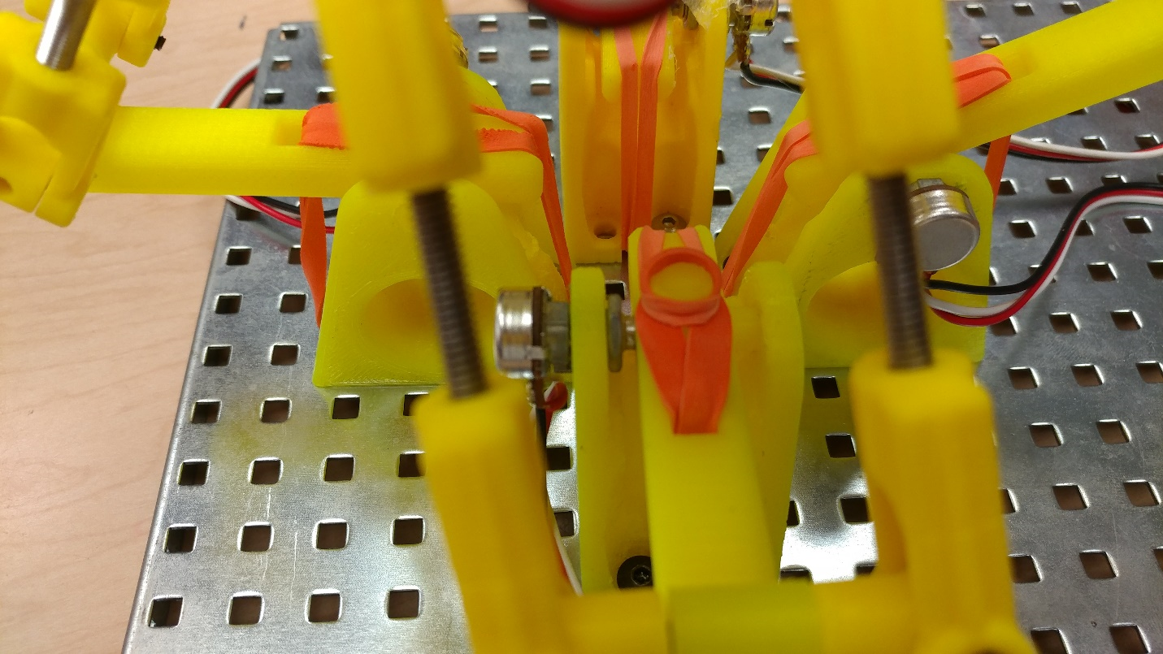A close interior views of the Joystick, showing rubber bands and potentiometers

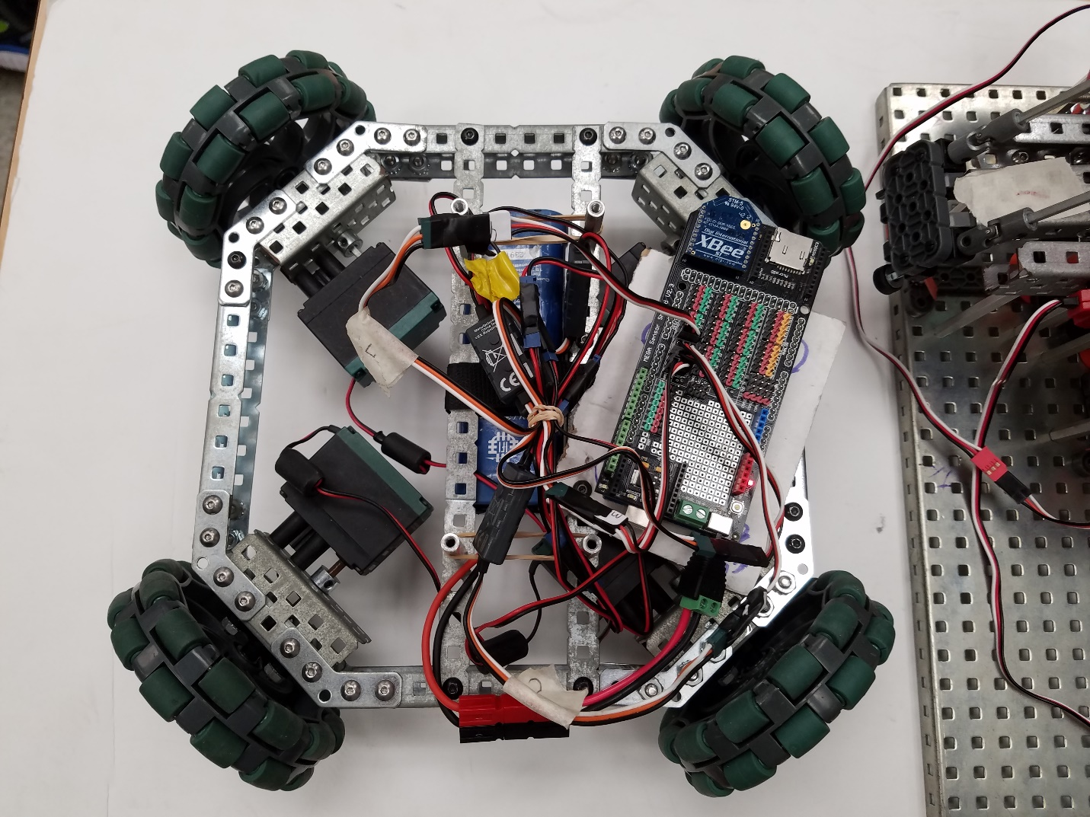

The finalized test vehicle, with the vertical lift removed for visual clarity

# Reflections

## Overall Review

When I started this project, I began with the first, rough prototype designed out of Vex pieces. This rough design gave me an opportunity to better understand the kind of layout the finalized joystick would demand. Testing to find optimal mount positioning was done, and it ultimately was an important step to realizing the final product. After this, working with the second, metal prototype developed by Mr. Ness gave me an opportunity to get into the meat of the project. This prototype was developed into a working joystick, but difficulties were encountered in programming. Ultimately, no progress could be made that would allow the data to transmit from the joystick, so that phase of the project was halted. Following that development, work began with the final product. The 3D Printed final joystick was assembled to completion, after some difficulties, and potentiometers were installed. A grip for the joystick was custom designed and printed, and was eventually installed on the joystick. The joystick was wired to an Arduino, and work began on the process of transmitting the data and making the joystick useful. This was done with the aid of a peer, who was far more knowledgeable about the process. This collaboration lead to success, quickly developing a solution to transmit the values, interpret them and allow the test vehicle to respond to the joystick.

## Meeting Goals

The primary goals of this project were:

1. Create a functioning drone control mechanism
2. Control the drone in 3 dimensions, as well as rotation angle.
3. Create a stable and long lasting design that is sturdy and strong, but also mobile

These goals initially were lofty, but they were met to a reasonable standard. The original goals called for the creation of a drone control mechanism, which remains the ultimate extension of this project. However, difficulties in transmitting data have limited the application of the joystick thus far to a simple test vehicle. However, the nature of the test vehicle mirrors that of a drone to some extent. And because the test vehicle has been successfully controlled by the joystick, I am willing to label goals 1 and 2 as at least partial successes. Goal 3 has also been achieved, with our 3D printed joystick being both stable and mobile, to the extent that its mounting plate can be easily relocated. Overall, though the application of the joystick has been more limited than intended, it is fair to say the project was, at least partially, a success in relation to the primary goals.

The major roadblock here was the period when worked stalled with the second prototype. The inability to overcome the glitches and numerous problems plaguing the transmission of data and Arduino codes slowed down progress immensely. These failures can likely be blamed on my inexperience with Arduino. Beyond that, other roadblocks simply included the fragility of the prototype joysticks. A decent amount of time was spent fixing them, and their construction/repair too often included mistakes I had made, which led to the necessity of further corrections.

The secondary goals of this project were the following:

1. 3D Print most if not all components of the joystick
2. Incorporate wireless communication methods into the joystick itself
3. Include the ability to customize into the joystick, such that factors like height can be changed to be most comfortable for the user.

These secondary goals were met by similarly mixed success. Goal 6 was not met, as this would have proven to be far to difficult, considering the difficulties dealing with a one-size fits all joystick. Despite this failure, goals 4 and 5 were both full successes. Our joystick was overwhelmingly 3D printed, except where metal was more appropriate, and the data was successfully transferred wirelessly. I am pleased with these results.

## Future Applications

This project has numerous applications going forward. The most direct of these the development of this actual project itself to be a control mechanism for a drone. This was the original intended goal, and while that proved impossible to achieve this year, what has been done stands as a clear proof of concept for continued work. Going forward with a drone will require two major developments that I can foresee. The first is increased precision in the joystick. The imperfections in our joystick have been mostly negated by our use of cardinal direction methods and implementation of thresholds for movement, but these would prove problematic for a drone. On a drone, every movement matters, and there is a lot more that can go wrong than a simple robot on the ground. So that will have to be addressed. The second, is a new programming system, in which the drone can respond to the actual position of the joystick, not just complete a method that has been activated. This would probably have to be developed through testing on the ground vehicle. These are difficult to accomplish tasks, but they are within reason.

Outside of these direct applications, this technology could be applied to a great many other projects. For example, one might examine the possibility of using this joystick with a robotic arm. Alternatively, this joystick could be directly interfaced with a computer, as a method of control for simulations or games that have been developed. This style joystick is far more appropriate in many situations to a regular joystick, or a simple controller, so finding those situations will be important.

## Lessons Learned

This project, however difficult it was, left me with several valuable lessons. The major thing I walked away with was a better understanding of Arduino. Working with my peer Nikhil to overcome the challenges faced helped make me a better programmer. I gained an understanding of the management of serial data, as well as the process of transmitting that data. In general, my competency level was increase dramatically towards the end of this project. Beyond that, I also developed in my ability to work with wiring. I gained increased experience soldering the potentiometers, and crimping the wires. I am still not the best at soldering – largely due to my shaky hands – but I definitely got better at it. I also learned how not to crimp wires through my mistakes, and I feel confident I could successfully do so now. Finally, I learned 3D printing with this project. Developing the grip for the top of my joystick was one of my first experiences with 123D Design, and I was able to learn the software pretty well. I also gained an understanding for the process of printing something, from design to actual settings on the printer itself.

# Final Code

Joystick Code

~~~~~~~~~~~~~~~~~~~~~~~~~~~~~~~~~~~~~~~

int pot1 = 0;

int pot2 = 0;

int pot3 = 0;

int pot4 = 0;

int pot5 = 0;

String in = "";

void setup() {

// put your setup code here, to run once:

Serial.begin(9600); //Serial Monitpr

Serial1.begin(9600); //Xbee Device

delay(500);

}

void loop() {

// put your main code here, to run repeatedly:

pot1 = analogRead(A0)-76; //sensor 1

pot2 = analogRead(A1)+300;//sensor 2

pot3 = analogRead(A2)-221;//sensor 3

pot4 = analogRead(A3);//sensor 4

pot5 = analogRead(A4);//sensor 5

slider = analogRead(A5);

//Serial.print("Pot 1: "); //POT 1 is GOOD

//Serial.println(pot1); //POT 1 is GOOD

Serial1.println(pot1);

//Serial.print("Pot 2: ");

//Serial.println(pot2); //POT 2 is GOOD

Serial1.println(pot2); //POT 2 is GOOD

//Serial.print("Pot 3: ");

//Serial.println(pot3); //POT 3 is GOOD

Serial1.println(pot3);

//Serial.print("Pot 4: " );

//Serial.println(pot4); //POT 4 is GOOD

Serial1.println(pot4);

//Serial.println(pot5); //POT 5 is GOOD

delay(250);

}

~~~~~~~~~~~~~~~~~~~~~~~~~~~~~~~~~~~~~~~

Test Vehicle Code

~~~~~~~~~~~~~~~~~~~~~~~~~~~~~~~~~~~~~~~

#include <Wire.h>

#include <Servo.h>

#define echoPin 7 // Echo Pin

#define trigPin 8 // Trigger Pin

Servo frontleft, frontright, backleft, backright, Ymotor;

String iS, iS2, iS3, iS4;

int pot1, pot2, pot3, pot4;

long duration, distance;

void setup() {

// put your setup code here, to run once:

Serial.begin(9600);

Serial1.begin(9600);

frontright.attach(14);

frontleft.attach(17);

backleft.attach(15);

backright.attach(21);

Ymotor.attach(27);

pinMode(trigPin, OUTPUT);

pinMode(echoPin, INPUT);

delay(500);

}

void loop() {

// put your main code here, to run repeatedly:

if(Serial1.available() > 0){

iS = Serial1.readStringUntil('\n'); pot1 = iS.toInt();

iS2 = Serial1.readStringUntil('\n'); pot2 = iS2.toInt();

iS3 = Serial1.readStringUntil('\n'); pot3 = iS3.toInt();

iS4 = Serial1.readStringUntil('\n'); pot4 = iS4.toInt();

//Serial.print("Pot 1: "); Serial.println(pot1);

//Serial.print("Pot 2: "); Serial.println(pot2);

//Serial.print("Pot 3: "); Serial.println(pot3);

//Serial.print("Pot 4: "); Serial.println(pot4);

if(pot1 > 0 && pot2 > 0 && pot3 > 0 && pot4 > 0){

if(pot1 > 600 && pot3 < 400){

Serial.println("Move Forward");

moveMotorsForward();

}

else if(pot3 > 600 && pot1 < 450){

Serial.println("Move Backwards");

moveMotorsBackward();

}

else if(pot2 > 600 && pot4 < 400){

Serial.println("Move Left");

moveMotorsLeft();

}

else if(pot4 > 600 && pot2 < 400){

Serial.println("Move Right");

moveMotorsRight();

}

else if(pot1 < 500 && pot2 < 500){

Serial.println("Move Up");

moveYMotorUp(); }

else if(pot1 > 600 && pot2 > 600){

Serial.println("Move Down");

moveYMotorDown();

}

else{

Serial.println("Default State");

stopMotors();

}

}else{

Serial.println("One or more of the potentiometers are off");

}

}

else{

Serial.println("Serial 1 Not Online");

}

delay(250);

}

void moveMotorsForward(){

delay(250);

frontleft.write(150);

backleft.write(150);

frontright.write(20);

backright.write(20);

}

void moveMotorsBackward(){

delay(250);

frontleft.write(20);

frontright.write(150);

backleft.write(20);

backright.write(150);

}

void moveMotorsRight(){

delay(250);

frontleft.write(150);

frontright.write(150);

backleft.write(20);

backright.write(20);

}

void moveMotorsLeft(){

delay(250);

frontleft.write(20);

frontright.write(150);

backleft.write(20);

backright.write(150);

}

void stopMotors(){

Ymotor.write(0);

frontleft.write(0);

frontright.write(0);

backleft.write(0);

backright.write(0);

}

void moveYMotorUp(){

Ymotor.write(130);

Serial.println("Move Up");

}

void moveYMotorDown(){

Ymotor.write(20);

Serial.println("Move Down");

}